**TCI SAP S/4 HANA Implementation**

Technical Specification – EDD 243

**CLAIMS PROCESSING SYSTEM**

**Version : 1.0**

**Date Created : 25-07-2019**

**Author : MINAKSHI SINGH MEHTA**

**Document Information**

|  |  |
| --- | --- |
| GAP/CR ID |  |
| FS Definition Form ID | EDD257 |
| Type of development | UI5 |
| SAP R/3 Version | S/4HANA ON PREMISE 1709 |

**Approval**

|  |  |  |  |  |
| --- | --- | --- | --- | --- |
| Approved by | Name | Role | Signature | Date |
| Process Team Lead |  |  |  |  |
| Development Team Lead | Parshuram Arsul |  |  |  |
| TCI System Analyst |  |  |  |  |

**Document History**

|  |  |  |  |
| --- | --- | --- | --- |
| **Version** | **Author** | **Reason for change** | **Date** |
| 1.0 | Minakshi Singh Mehta | Initial draft | 26-07-2019 |
| 1.1 | Minakshi Singh Mehta | INC0196563 | 16-10-2021 |
| 1.2 | Vatsavai Swetha | DMND0004037 | 31-07-2023 |
| 1.3 | Vatsavai Swetha | DMND0003836 | 20-09-2023 |

|  |
| --- |
| **Related Documents** |
| <Reference document name and location link> |
|  |

Table of Contents

1. General Information 4

2. Description and Purpose 4

3. Assumptions 4

4. Issues 4

5. Dependencies 5

6. Technical Details 5

7. Models Details 11

8. Views Details 11

9. View Controllers Details 12

10. Fragments Details 14

11. Component JS Details 14

12. Formatters Details 14

13. Patterns Details 14

14. ODATA-Gateway (Back-end) 15

15. Data Source consideration 15

16. Data Validation 16

17. Error Handling 16

18. Security Requirements/ Authorization Details 17

19. Additional Information and attachments 17

20. HANA Artifacts 17

21. Unit Test Plan 19

# General Information

|  |  |  |  |
| --- | --- | --- | --- |
| **WRICEF ID** | EDD 243 | | |
| **Description** | Warranty Claim Application Details | | |
| **Implementation Phase** | Wave 2 | | |
| **Transaction(s) (if applicable)** | N/A | | |
| **Package** | ZFIORI | | |
| **Message Class (if applicable)** |  | | |
| **Develop. Class** |  | | |
| **Module** | ODATA | | |
| **Enhancement User/User Group** |  | | |
| **Run Frequency** |  | **Language** | English, French |

| **GIT Information** |
| --- |

|  |  |  |  |
| --- | --- | --- | --- |
| **Sr.No #** | **Branch Name** | **User id** | **Repository URL** |
| **1** | claimprocessing | minakshi_singh@toyota.ca | https://git.ca1.hana.ondemand.com/d36z7bqhz1/claimprocessing |
|  |  |  |  |

# Description and Purpose

# Assumptions

User must be authorized to access the consolidated ECP Sales application. Depending on Logged in user roles User have access to see certain pages.

# Issues

**N/A**

| **Issue #** | **Date Raised** |  | **Issue Description** | **Issue Resolution** |
| --- | --- | --- | --- | --- |
|  |  |  |  |  |
|  |  |  |  |  |

# Dependencies

# Technical Details

* 1. Application Name: Claim Processing
  2. Type: XSA Multi Target Application
  3. Latest Version: 1.0.0
  4. UI5 Libraries: sap.ui.layout, sap.ui.core, sap.ushell, sap.m, moment JS
  5. Components: Device, Model, Dialog, Text, Filter, History, MessageBox, Fragment, Formatter, Custom Control
  6. Program Flow:
  7. Screens: Home Screen

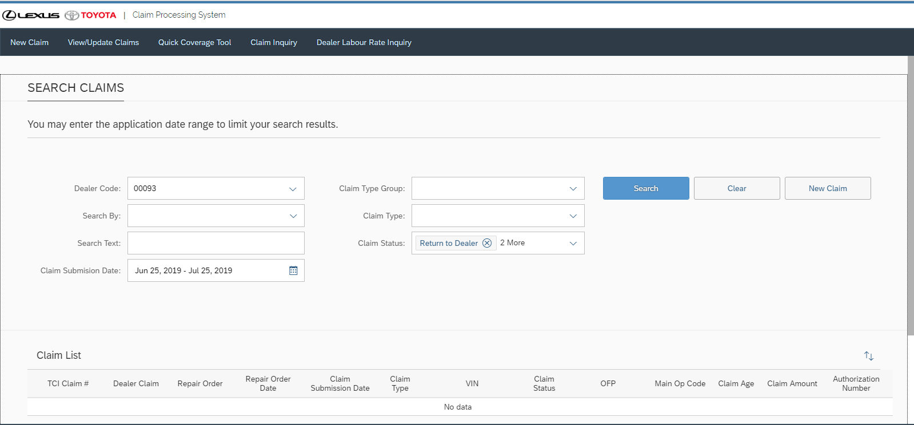

* 1. Screens: Home Screen Search 7 fields. 3 fields set by default user can change them. Search by VIN

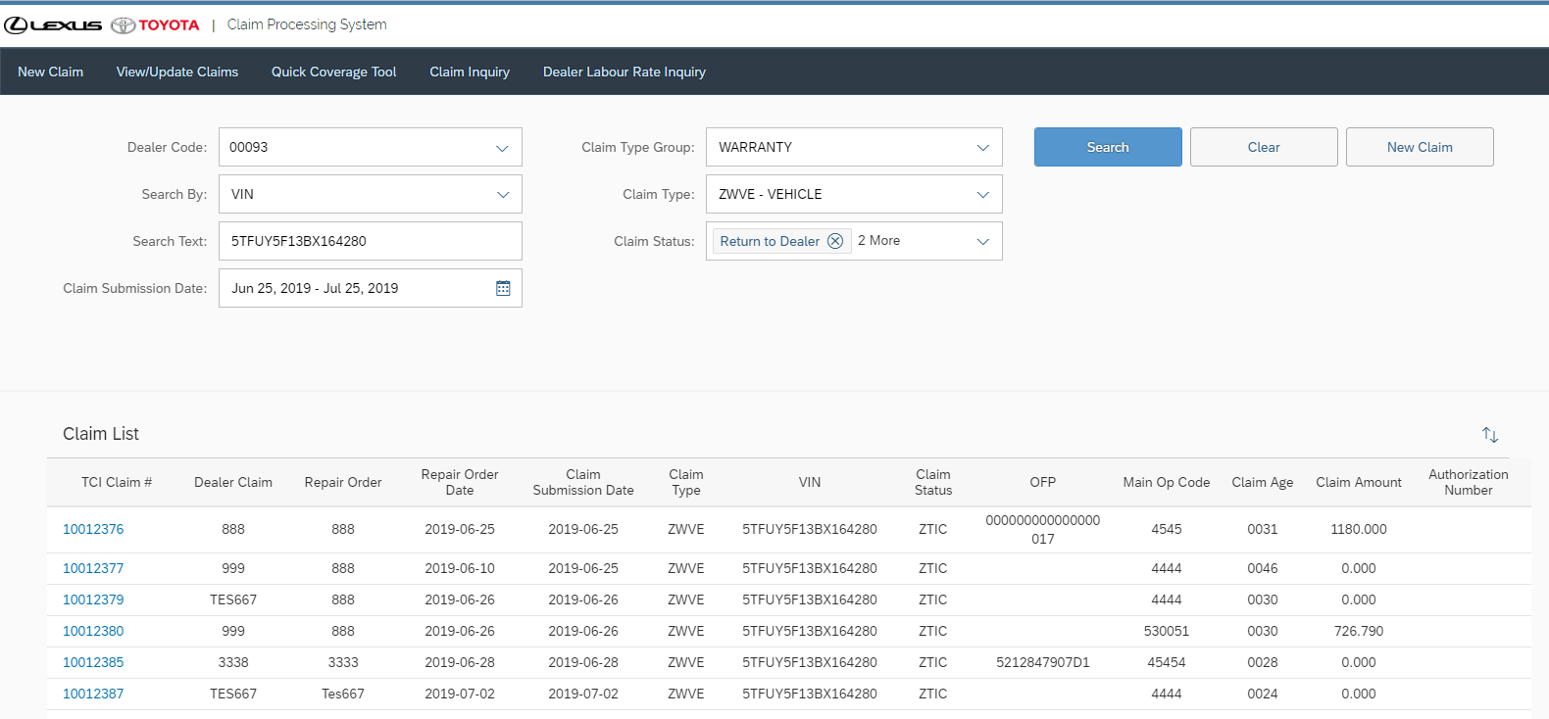

* 1. Screens: Home Screen Search by claim number .

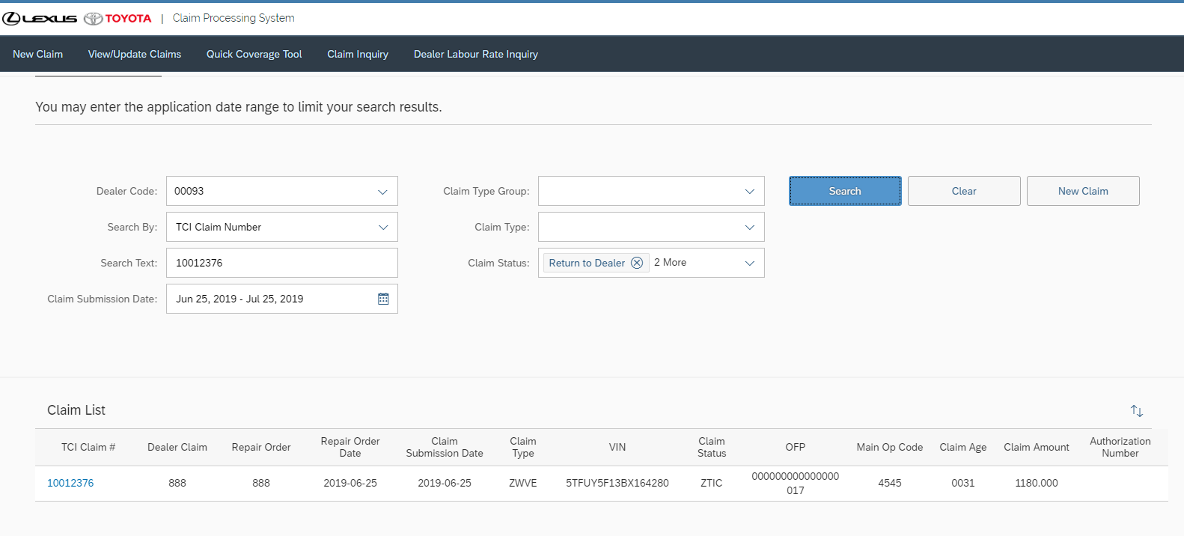

* 1. Screens: Home Screen Search by Claim Type Group 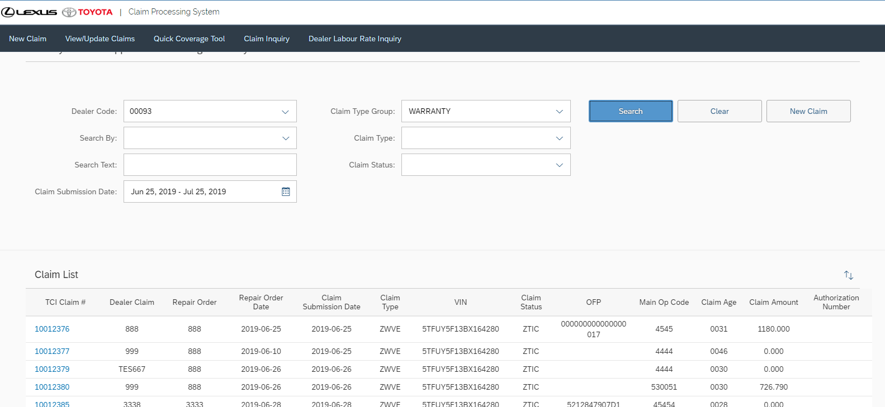
  2. Search by Claim group and claim type. 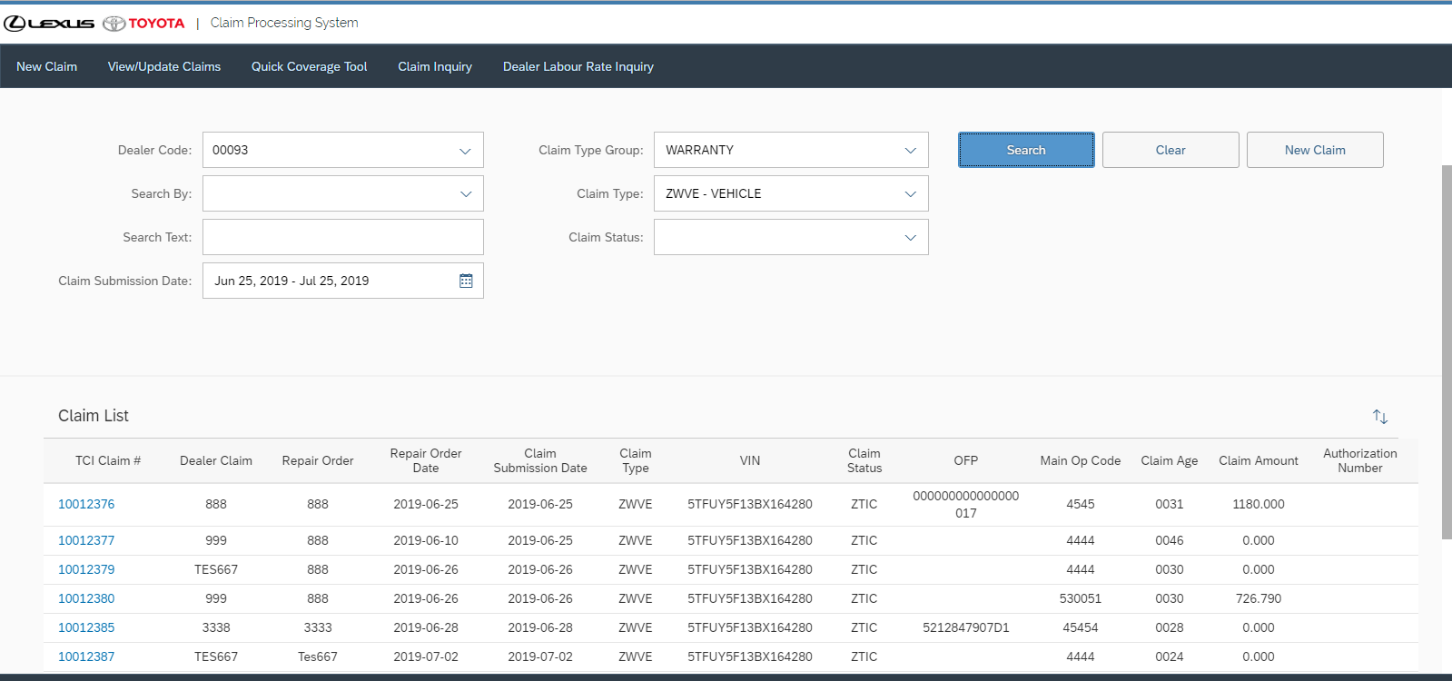
  3. Create New Claim Claim group type Warranty, Field Action, ECP, Vehicle Logistics, Customer Relations, SETR, Core Returns, Part Warehouse

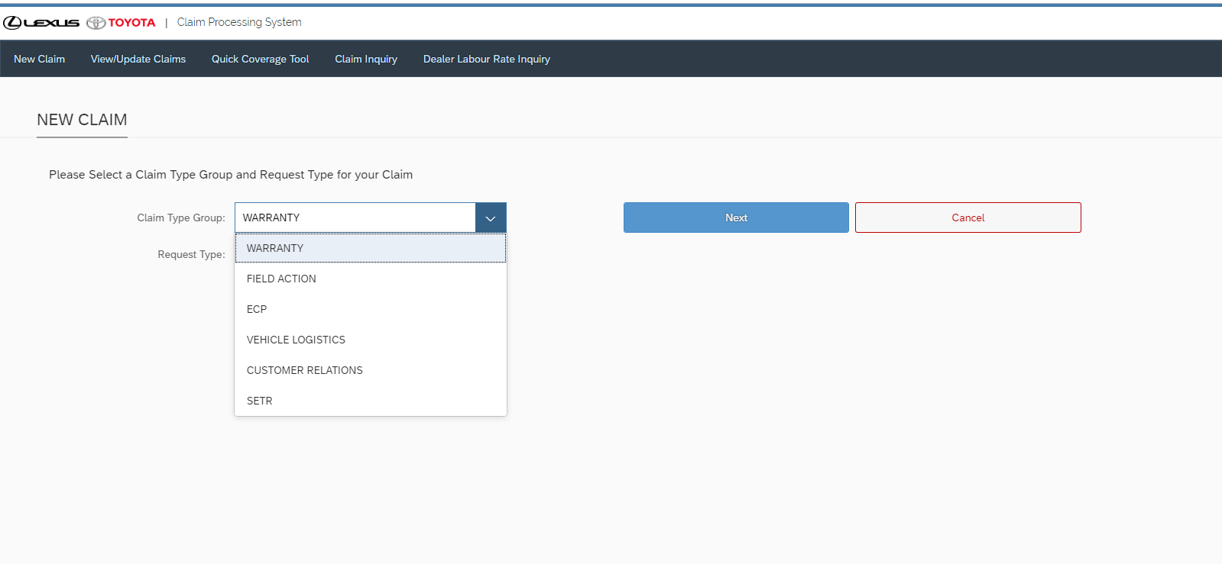

* 1. To Create Warranty there are 8 tabs for ZWVE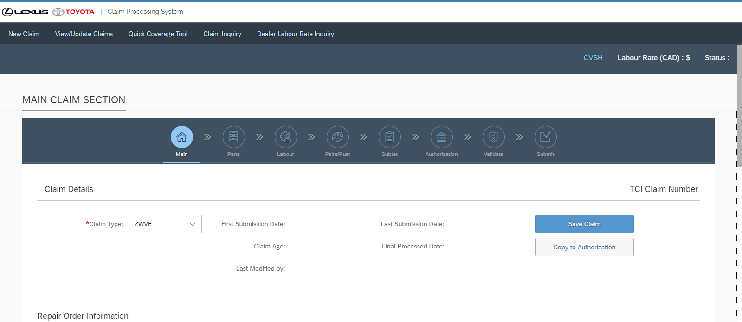
  2. To Create Warranty ZWA1 claim 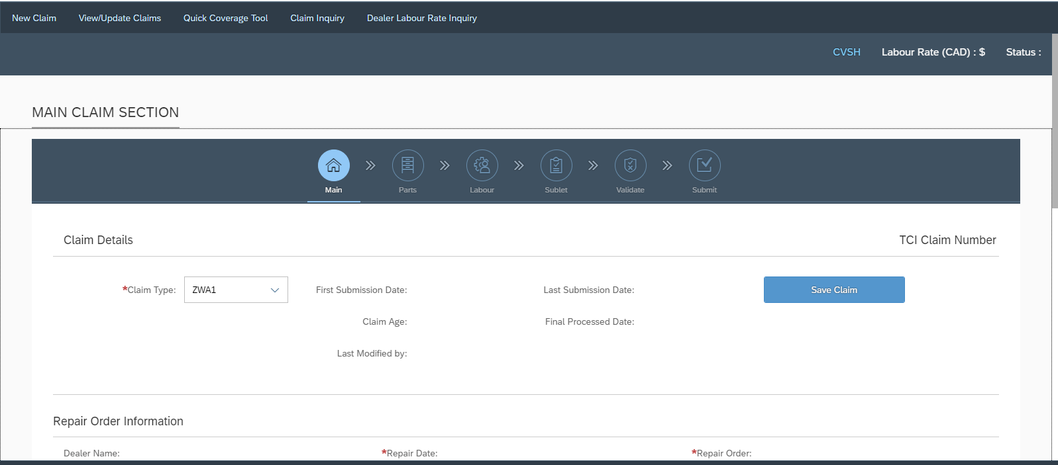
  3. To Create ZWA2 claim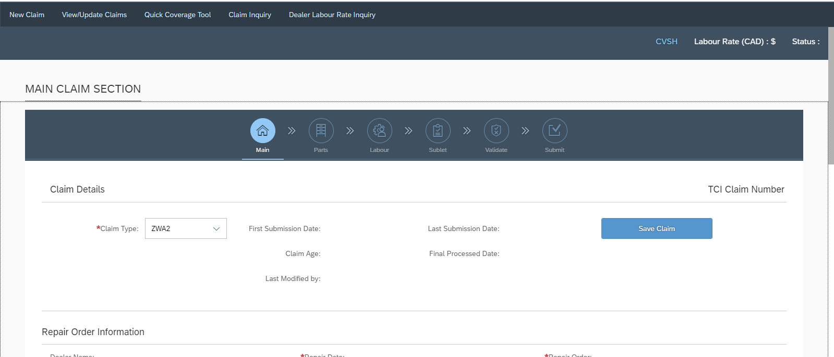
  4. To Create P2 Claims 5steps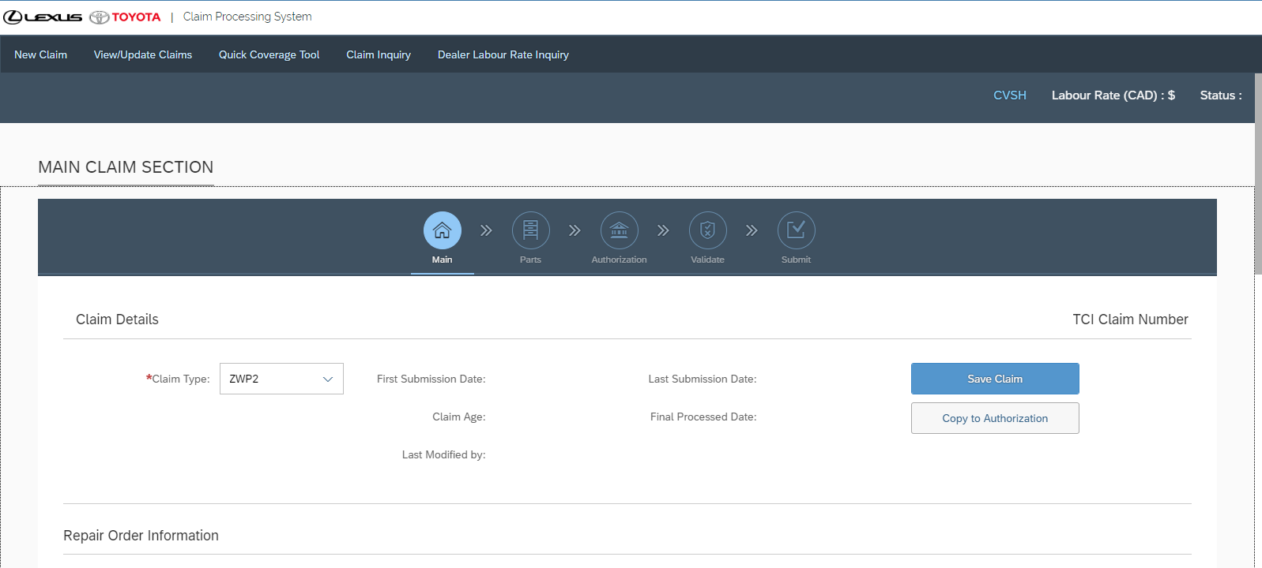
  5. To Create ZWMS claim 4 steps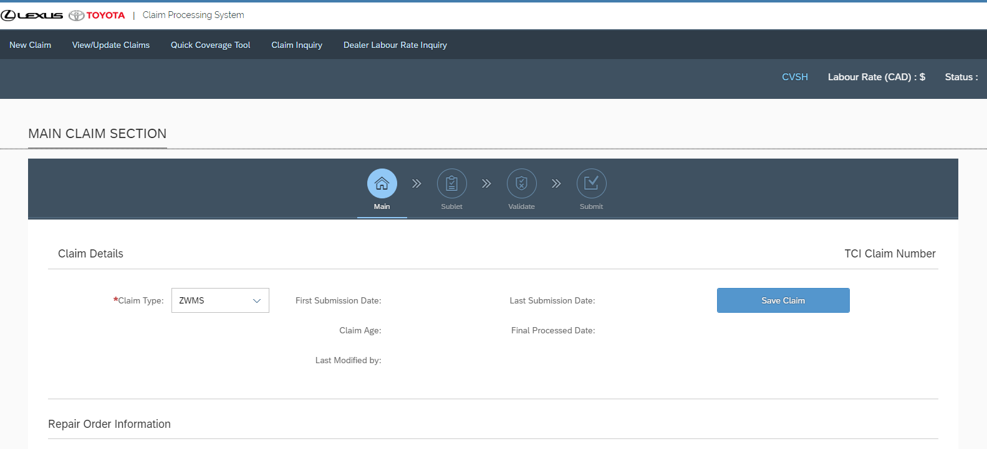
  6. To Create ZWAC claim 6 steps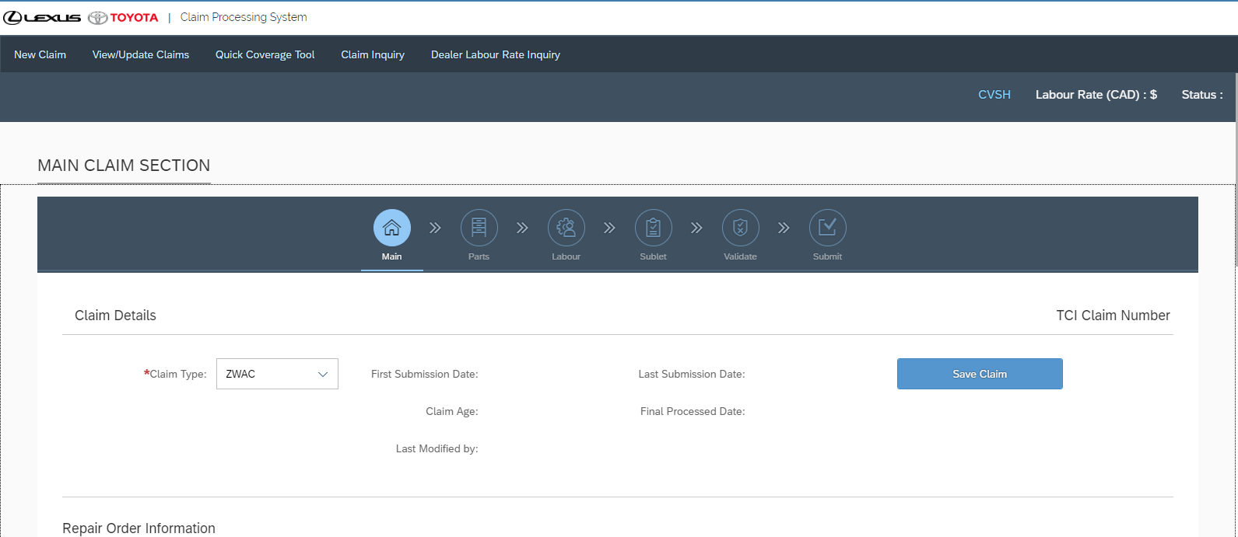
  7. Step 01 Form Section 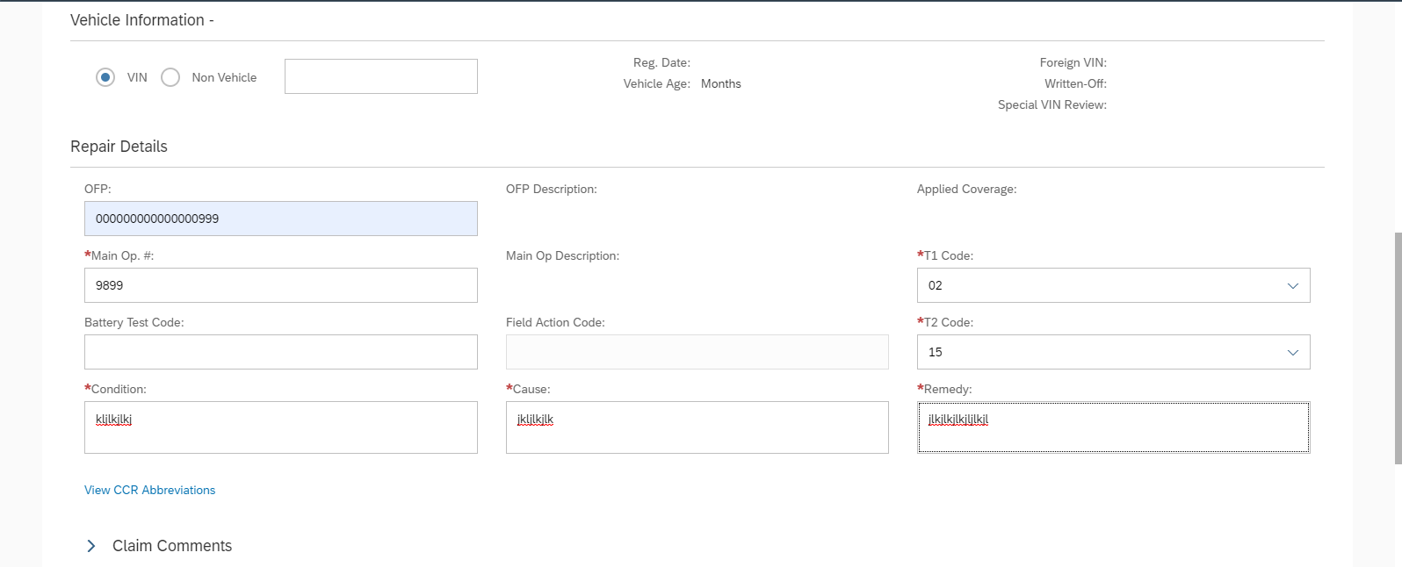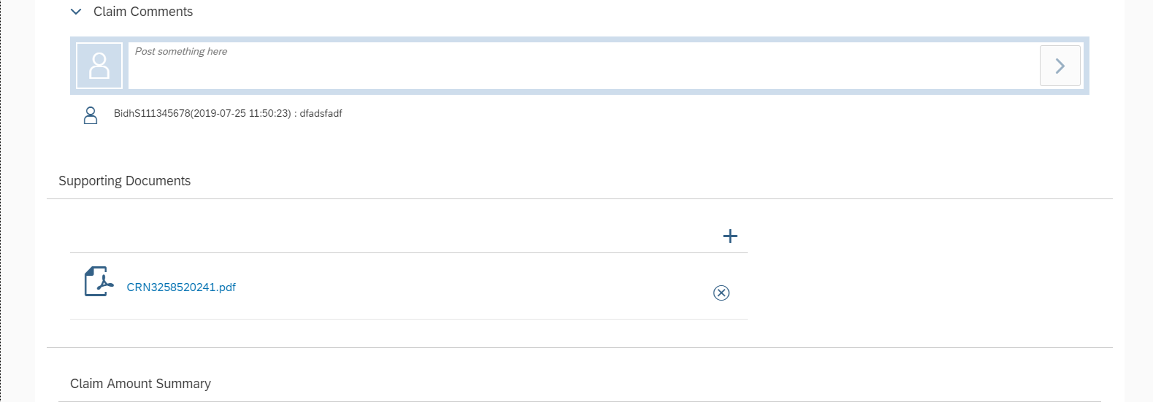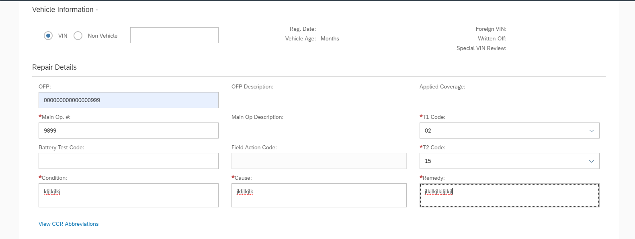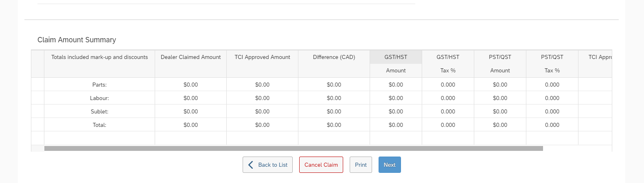
  8. Step 02 Form during create claim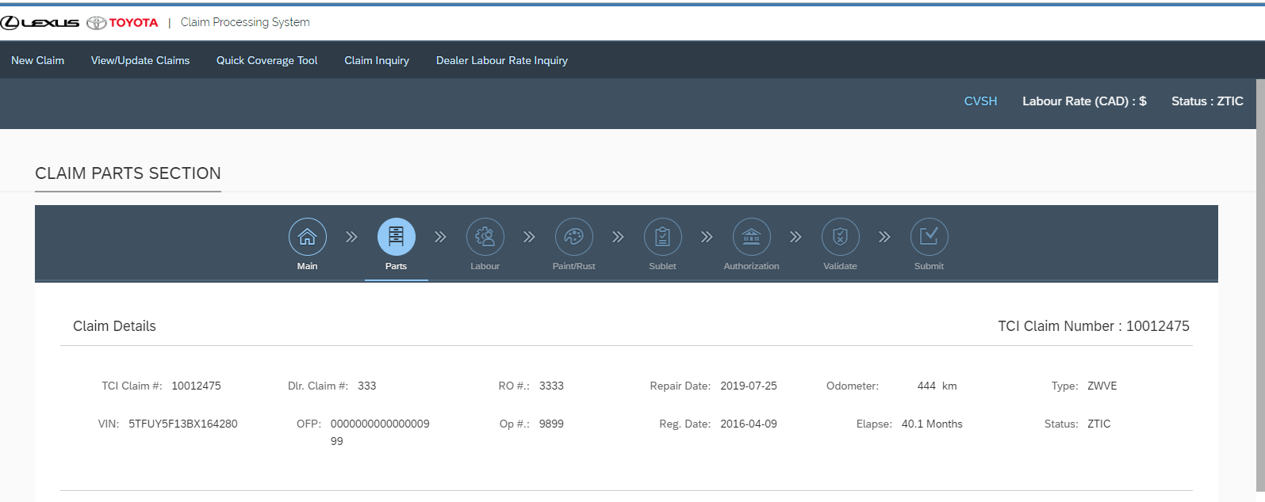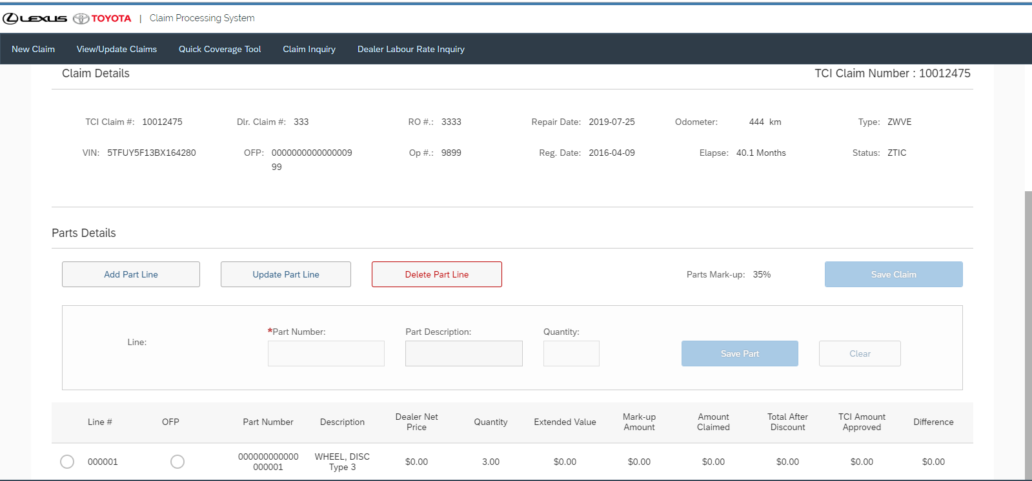
  9. Step 03 During create Claim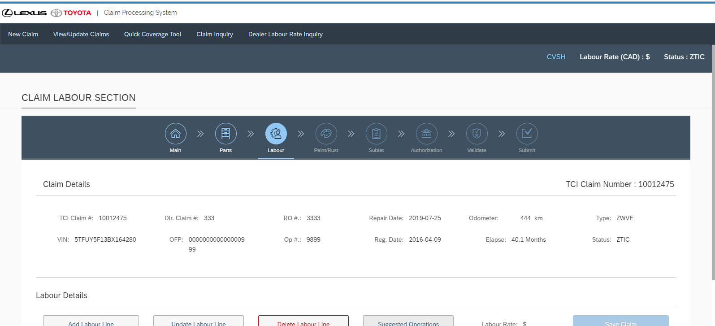

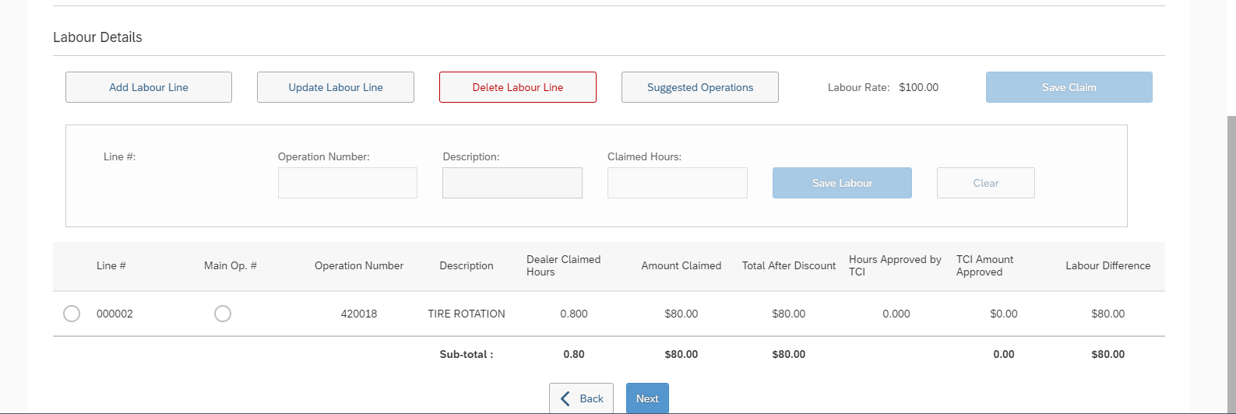

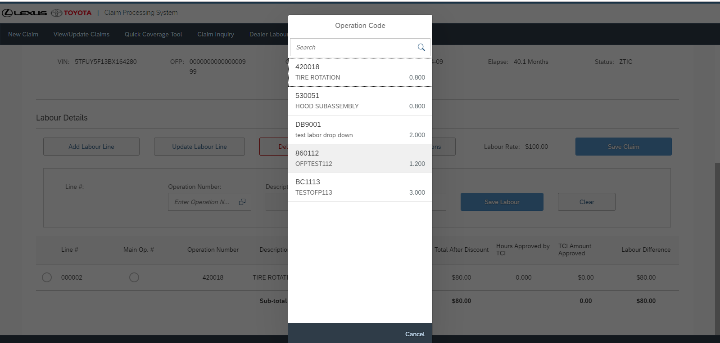

Step 04 during create claim

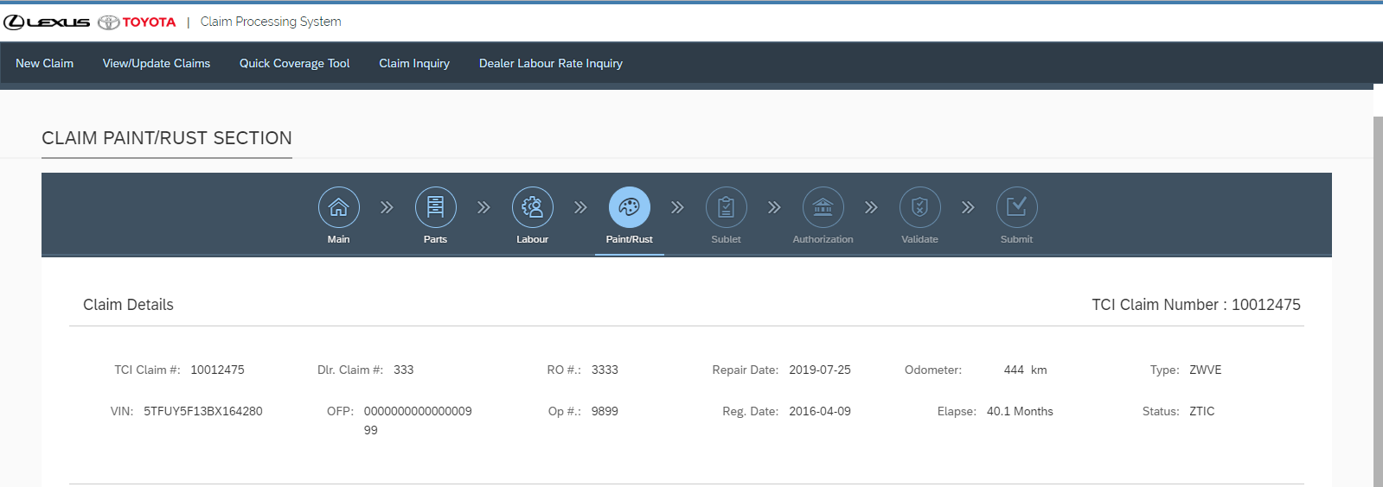

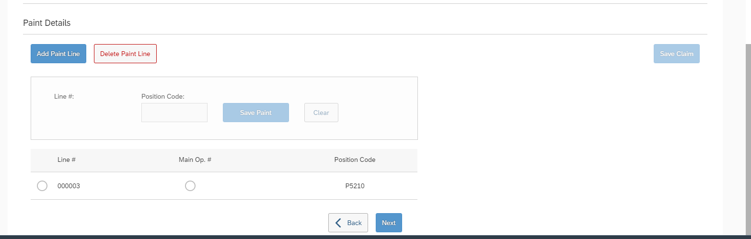

Step 05 to create claim

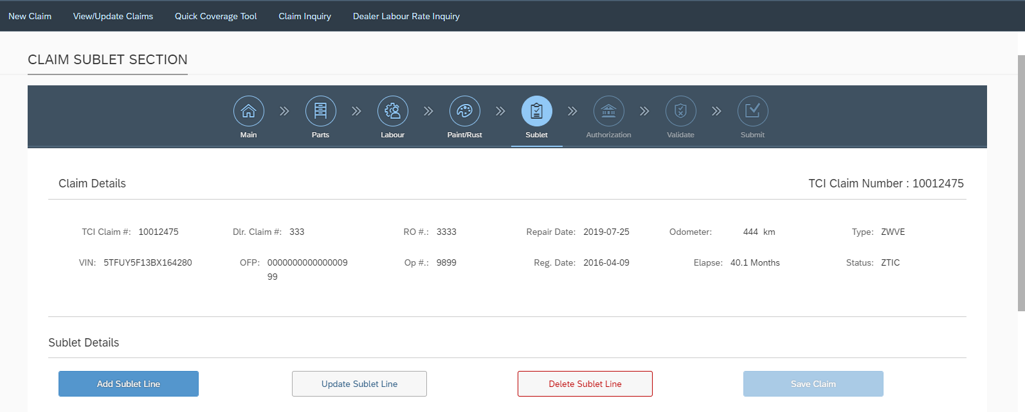 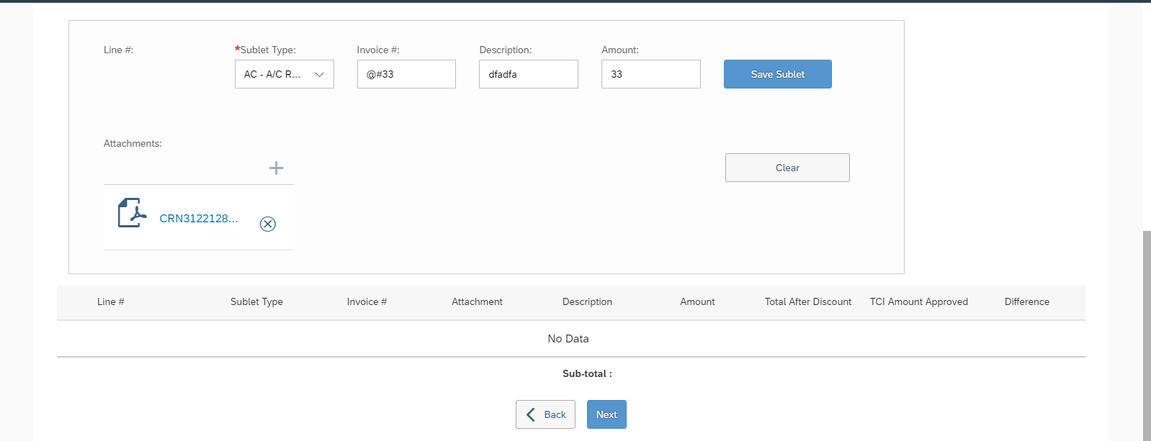

Step 06 to create claim

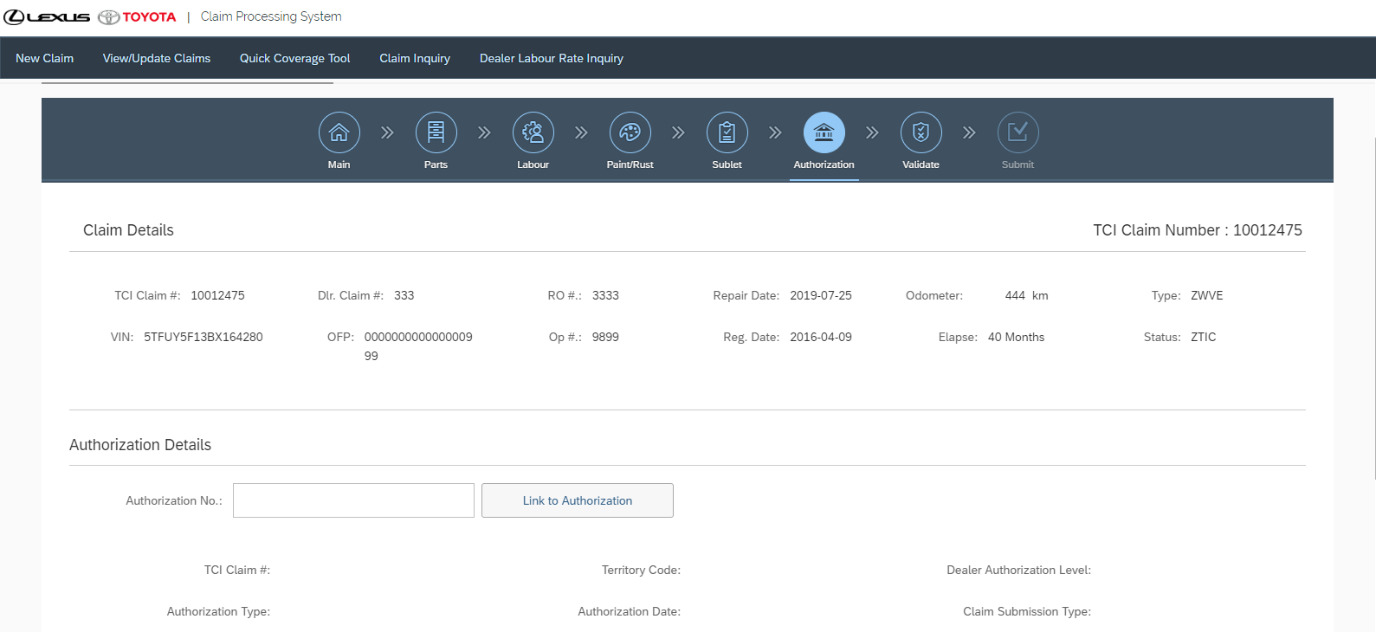 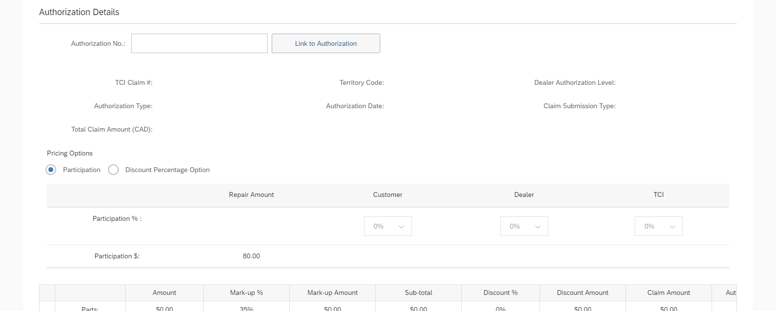 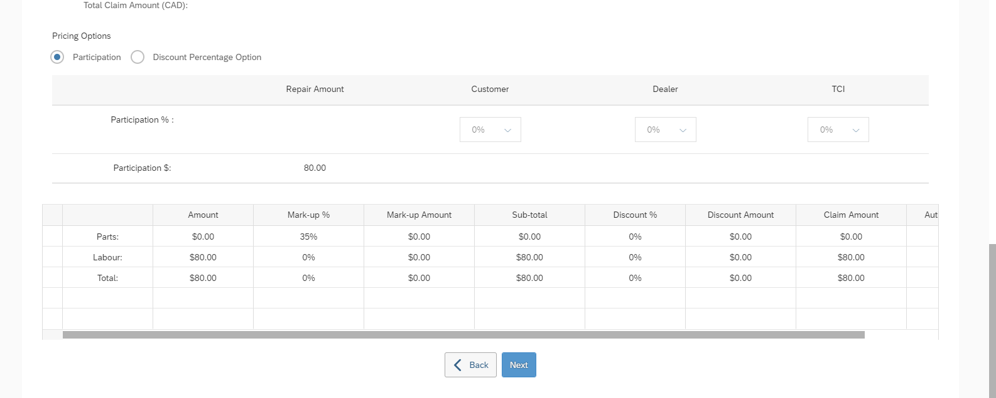

Step 07 and final step during create claim 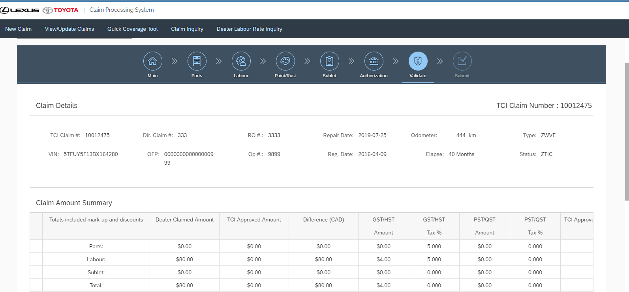

**Claim Inquiry Page**

Search by VIN and Date Range 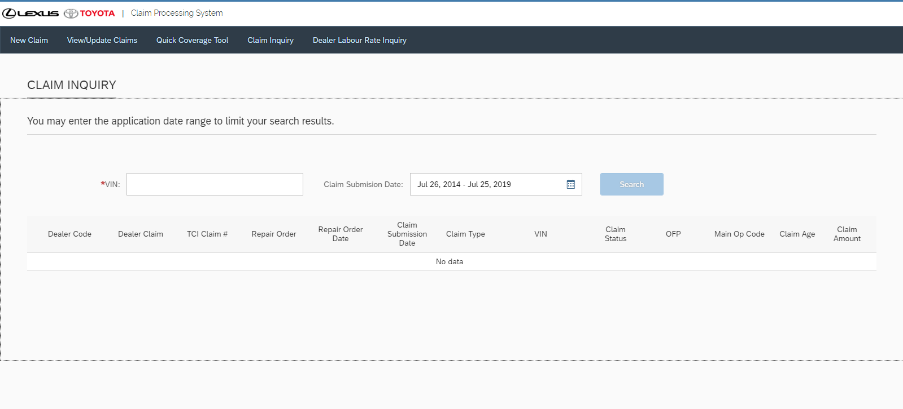 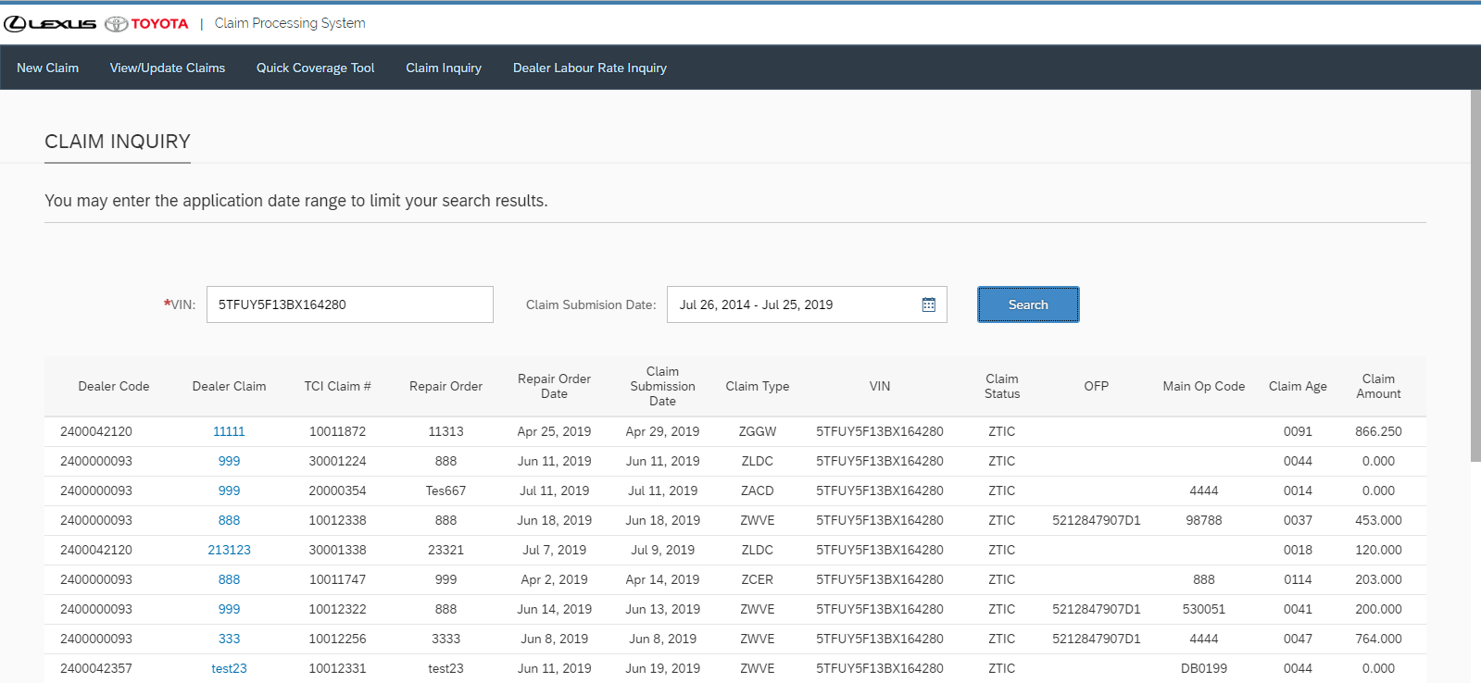

**Dealer Labour Rate Inquiry** 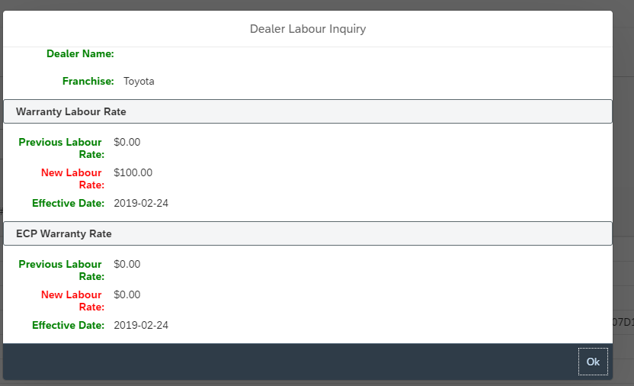

**Quick Coverage Tool**

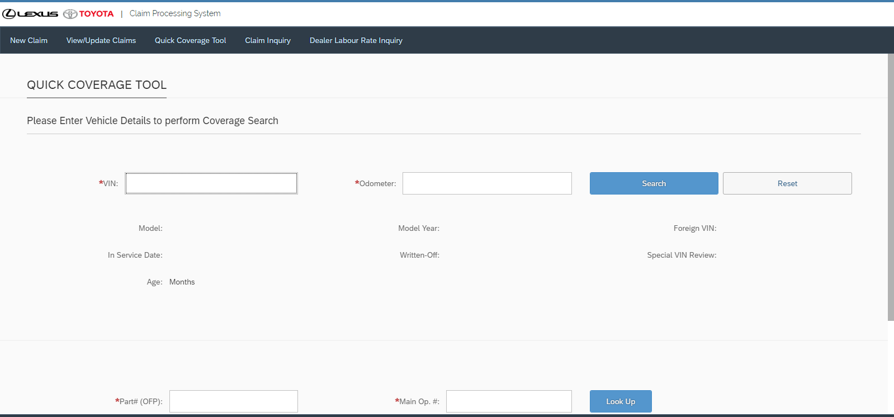 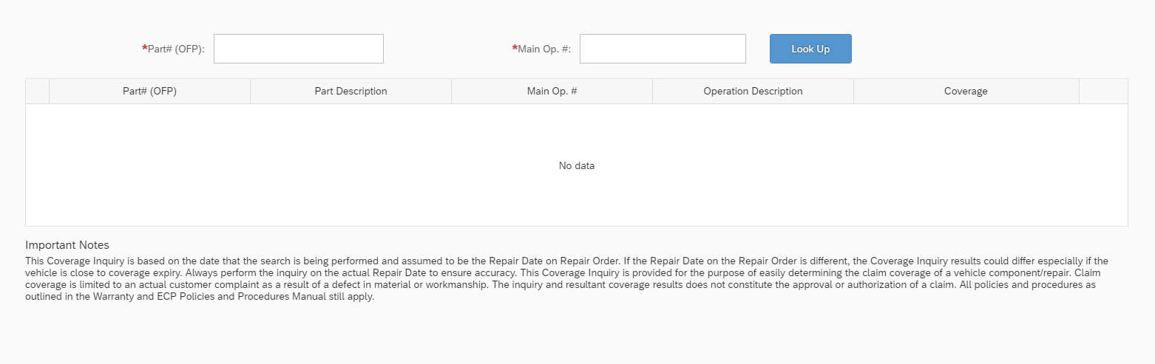

**Claim Details Page** 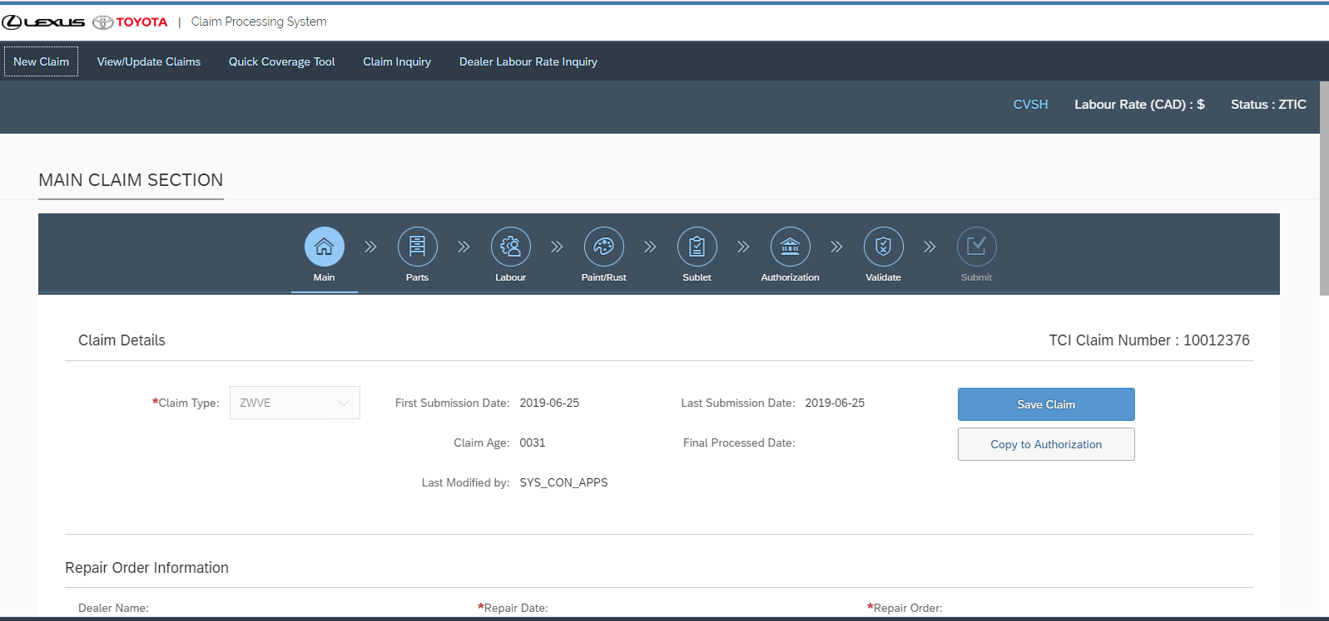

# Models Details

1. FitmentModel
   * Type: sap.ui.model.odata.v2.ODataModel

DataSource: ZDLR_CLAIM_SRV

1. Vehicle Info Model
   * Type: sap.ui.model.odata.v2.ODataModel
   * DataSource: Z_VEHICLE_MASTER_SRV
2. BusinessPartnerModel
   * Type: sap.ui.model.odata.v2.ODataModel
   * DataSource: API_BUSINESS_PARTNER
3. ECP Model

Type : sap.ui.model.odata.v2.ODataModel

DataSource: ZECP_SALES_ODATA_SERVICE_SRV/

XsodataModel

* + Type: sap.ui.model.odata.v2.ODataModel
  + DataSource: HANA DB

1. i18n
   * Type: sap.ui.model.resource.ResourceModel
   * BundleName: "zecp.i18n.i18n"
2. JSONModel
   * Type: sap.ui.model.json.JSONModel

# Views Details

* 1. **Master View**: View Update claims is the first page of the application User can search created application with 7 different type of search filters
  2. **Claim Details View : In search result when user click on claim it will take the user in search result page. If claim Status will be ZTIC or ZTRC user can edit claim otherwise user has no permission to edit claim**
  3. **New Claim : User Can create new Claim or Authorization selecting the claim type group**
  4. **New Claim Step01 – Main – Here user have to enter all mandatory fields and save then Claim create in this screen. After claim creation only User can input comments and Attachments in this same screen. After saving claim only user can go to next step**
  5. **New Claim Step 02 – Parts - Here User can Select Material Number from a dialog box and enter quantity then save part line will be saved. User can Create, Update and Delete part line.**
  6. **New Claim Step 03 - Labour – Here User can Select Operation Number from a dialog box and enter Claimed Hrs and save. Labour line will be created. User can Create, Update and Delete Labour Line**
  7. **New Claim Step 04 – Paint – Here User can Select Position code from a dialog box and save. Paint line will be created. User can Create and Delete paint line.**
  8. **New Claim Step 05 – Sublet – Here User can enter Sublet type from the dropdown, enter Invoice in Input, Description, Amount, Add attachment(mandatory), Days, Vehicle brand and save. Sublet line will be added. User can create, Update and Delete sublet line.**
  9. **Same Steps and some logic change done for Each Claim type group -ECP, Warranty, Vehicle Logistics, Core returns, Smart Part, Field Action, Customer Relation.**
  10. **New Claim Step 06 Authorization - Here if user have existing authorization they can Link Authorization with Claim. All the authorization details will be added in claim. In case of create Authorization User have to input all authorization details and save.**
  11. **New Claim Step 07 Validation - This is the final step. User can save claim as draft or can submit claim. After submit it will validate the form details and generate error or accepted by TCI in ZTAC status.**
  12. **Open Claim - From Search page when user click on any claim number It will show all claim details.**
  13. **Claim Inquiry - Here user can search with VIN number and date range all the claim created with the particular VIN number.**
  14. **Claim Inquiry Details Page - User can see all the details of the claim**
  15. **Quick Coverage tool – User can search by VIN and odometer and get results. With Valid part and Main Op code Search it will get Lookup details.**
  16. **Dealer Labour Rate - All the Labour Rates populate here.**

# View Controllers Details

* 1. **Base Controller - Get Scopes** 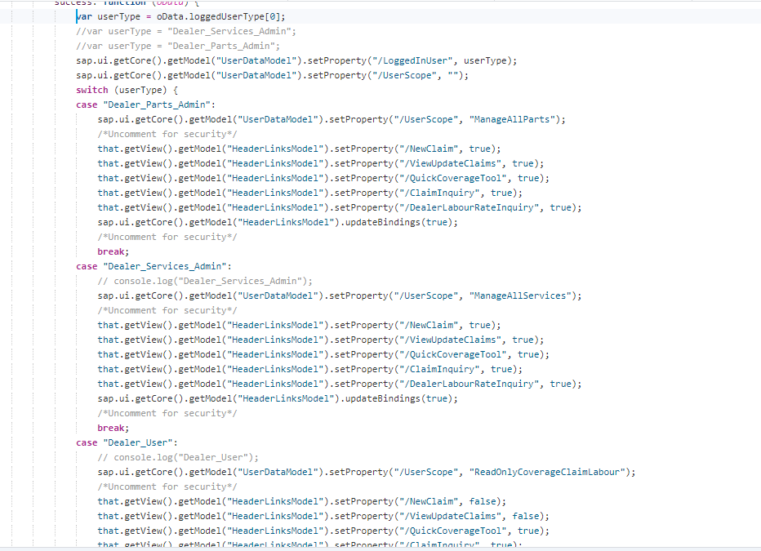
  2. Base Controller - Get Dealer 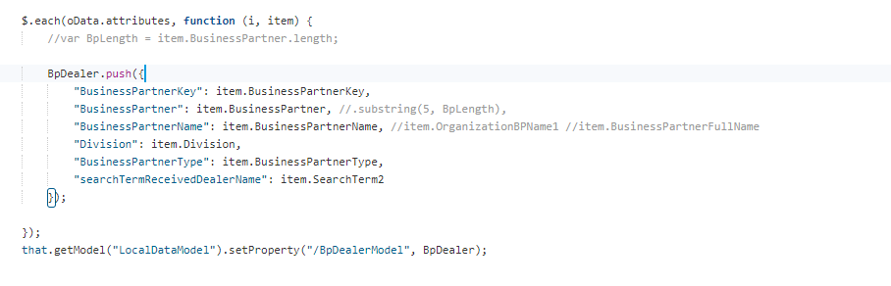
  3. handleLinkPress() for get header Navigation results. 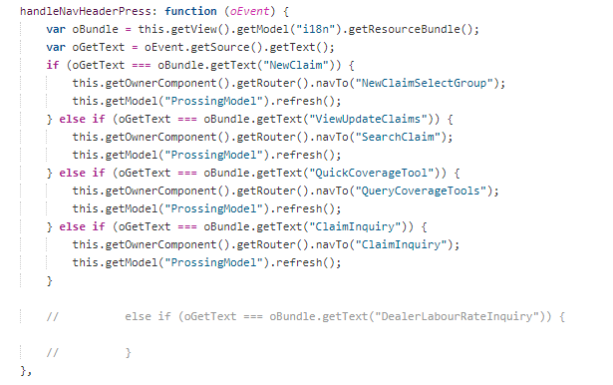
* onEnterSearchText () – In search text we can search by VIN, Claim Number, Agreement Number, Repair Order so all the conditions written here.
* onPressSearch () - Search Result logics.
* onPressClaim () – Nav to claim details page
* onCreateNewClaim () – go to Create New application page
* onSelectionChange() - On click list row it will take to application detail page.

**Change Fabicon - To get Fabicon based on division if division = 10 it will take Toyota for 20 It take Lexus. Title for French and English also change accordingly.**

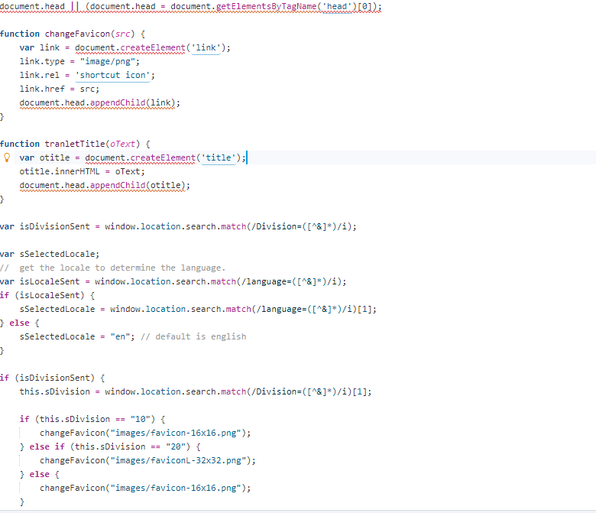

**Claim Inquiry –**

* onEnterVIN () - Check VIN validation
* onPressSearch() - Show search results
* onPressClaimInquiryDetails() - Nav to Inquiry details page

**New Claim Page – It will define for which group radio button will be selected**

onSelectClaimType()

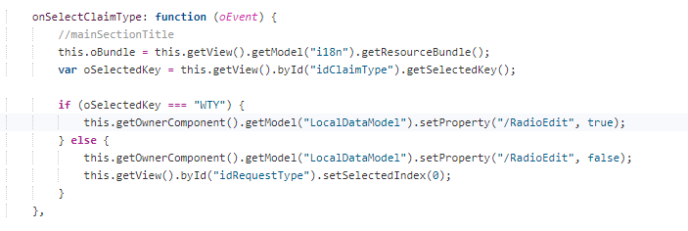

onClaimAuthorization() – Here logic written for all claim types so that depending on the claim type steps and mandatory fields will be change.

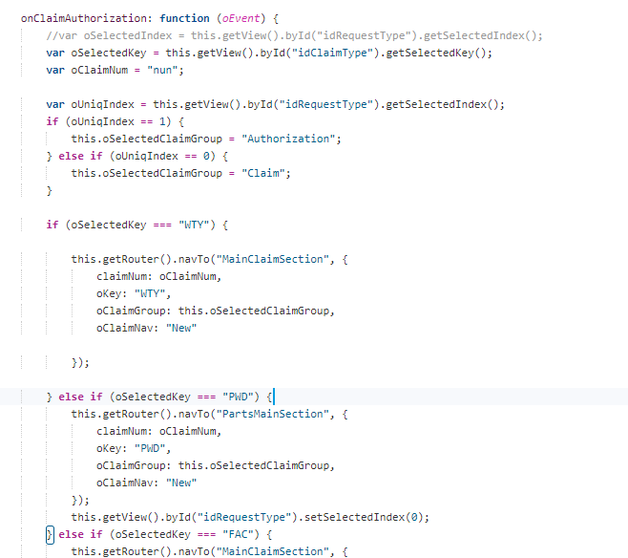

onPressCancel() - User back to search page.

**New Apllication Create steps**

onPost() – On post comment

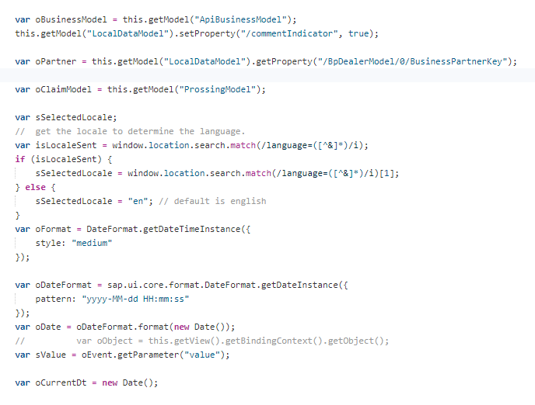

onSelectClaimTpe() – Select claim type from combobox logics maintained here.

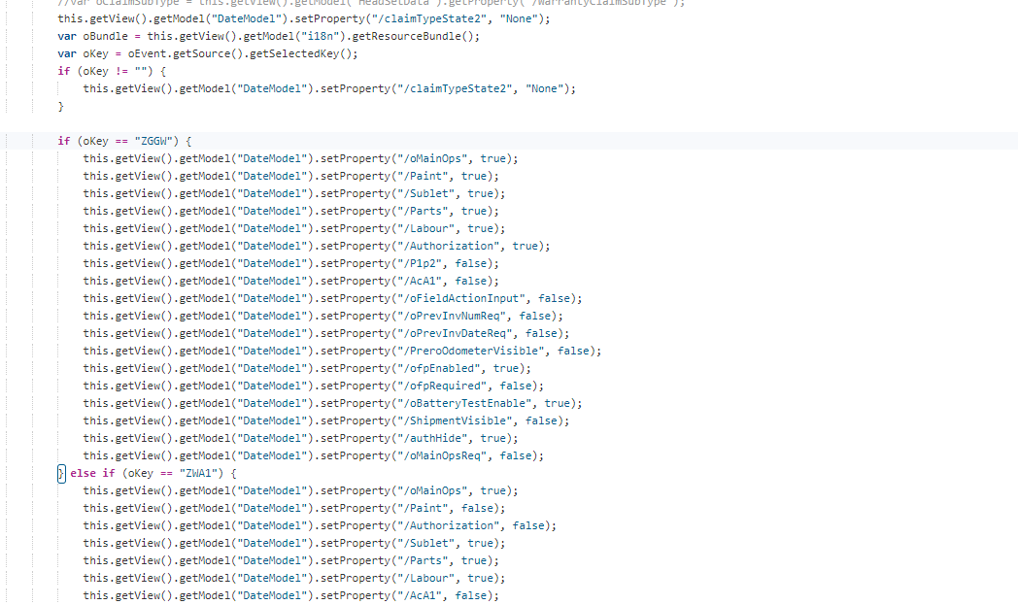

onEnterVIN () – Vin Validation logic and Vehicle details data logic written. 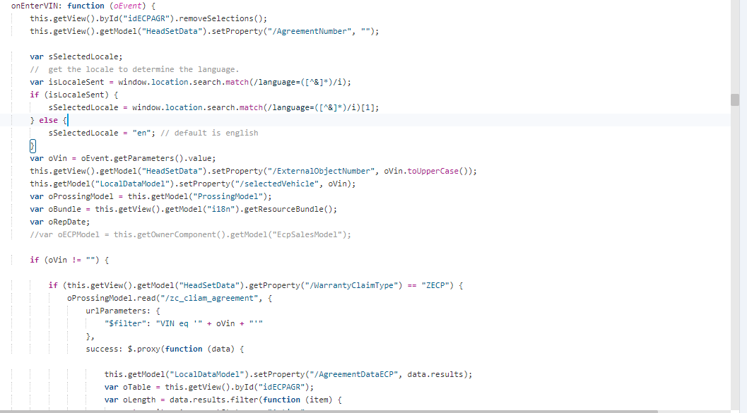

onPressAgreement() - Nav to ECP agreement page.

_fnDateFormat() – Date format logic.

_ValidateOnLoad() – All required input validation logic.

_fnSaveClaim() – On press save button it will validate all the fields

onCancelClaim() – Cancel claim logic writtern

onApproveClaim() – Approve claim by Manager logic written

onRejectClaim() – Reject claim by Manager logic writtern

_fnUpdateClaim() – Update claim data all the fields updated

onEditClaim() – ZTAC claim on edit logic.

_fnClaimSum() – Sum pricing calculation logic

onChangeMainOp() – Change Main op code logic

onChangeOFP() – OFP code change logic

onUplaodChange() – on Upload document logic

onFileSizeExceed() – File size limit popup

onUploadComplete() – On upload document complete logic

onFileDeleted() – Document delete logic

onPressTCIQty() – on Part page TCI approve quantity button press logics

onPressAddPart – Add part button press logic

onPressAddLabour() – Add Labour button press logic

onPressAddPaint() – Add Paint button press logic

onPressAddSublet() – Add Sublet button press logic

onPressRecalculate() – Recalculate button press logic

_fnPricingData() – Pricing data logic

onPressForeignVin() – Foreign Vin popup

onPressWrittenOff – Writtern off popup

onPressSpecialVin – Special Vin Popup

onCopyClaim – Copy claim or Athorization

onPressLinkAuthorization – Press link Authorization Button

onStep01Next() – Next button press on 1st step

onStep03Next – step 2 next button press

onStep04Next() – Step 4 next button press

onStep05Next() – Step 5 next button press

onStep05Back() – Step 5 back button press

onStep06Back() – Step 6 back button press

onStep02Next() – Step 2 Next button press

onStep02Back()

onStep07Back()

onSelectTab()

onPressBack()

fnOpenDialogOnBack()

handleValueHelp()

_handleValueHelpSearch()

onSelectAgreement()

onPressSavePart()

onFieldActionInput()

onPressUpdatePart()

onPressCancelPart()

onPressDeletePart()

onSelectOFP()

onSelectOFPLabour()

onSelectOFPPrint()

onPressSuggestLabour()

onCloseLabour()

onCloseRejectionCode()

onCloseLoop()

onSelectPositionCode()

_handleValueHelpSearchLabour()

_handleValueHelpCloseLabour()

_handleValueHelpClosePaint()

handleValueHelpPaint()

onSelectPositionPaintCode()

onSelectOperation()

onPressSaveClaimItemLabour()

onPressDeleteLabour()

onPressUpdateLabour()

onPressCancelLabour()

onPressSavePaint()

onPressCancelPaint()

onPressDeletePaint()

fnUrlFormat()

onPressUpdateSublet()

onPressDeleteSublet()

onPressCancelSublet()

onRevalidate()

onSaveDamage()

onAddDamageLine()

onUpdateDamageLine()

onDeleteDamageLine()

onSubmitTci()

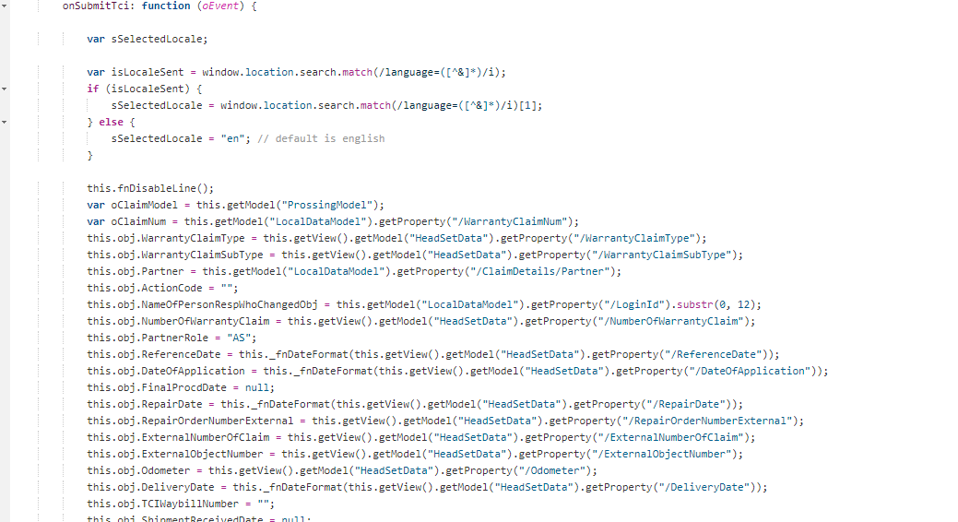

onPressPackingSlip()

onPressPrint()

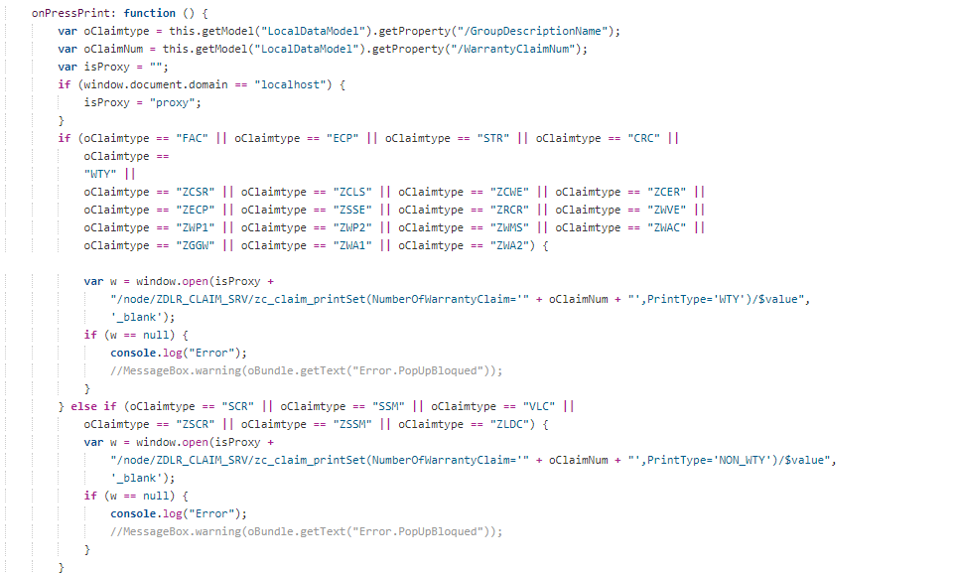

onPressSuggestPart()

onPressAbbr()

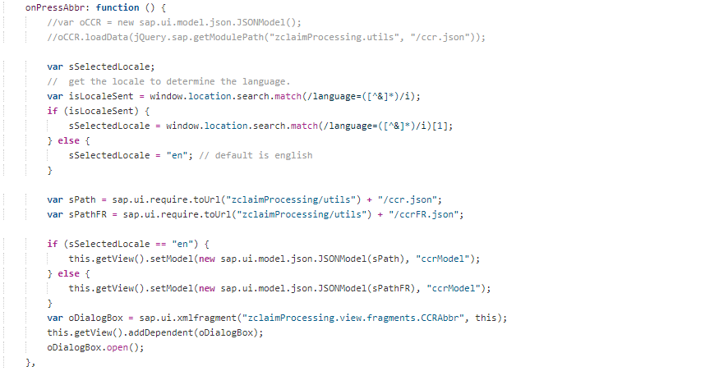

onChangeT1()

fnDisableLine()

onPressCIC()

onPressCVSH()

onSelectAuthPricingOpt()

**Quick Coverage Tool**

**onEnterVIN()**

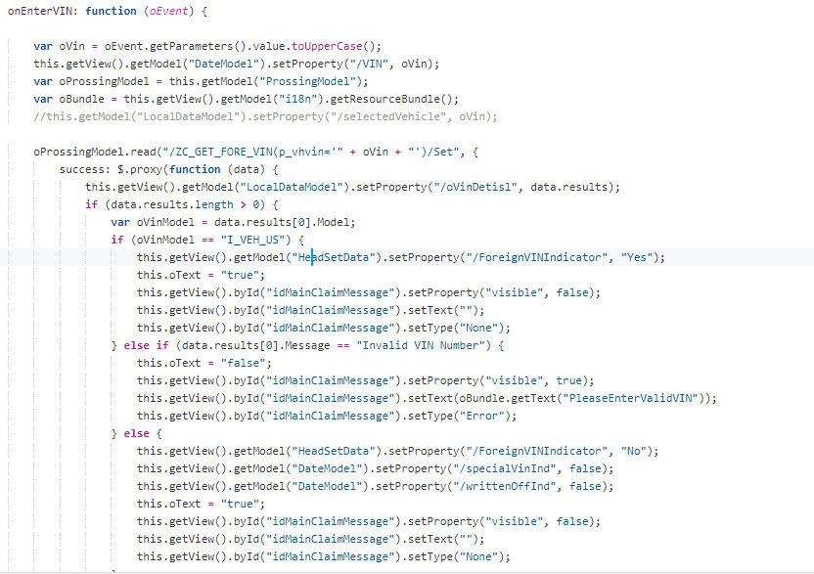

**handleDealerLabourInq()**

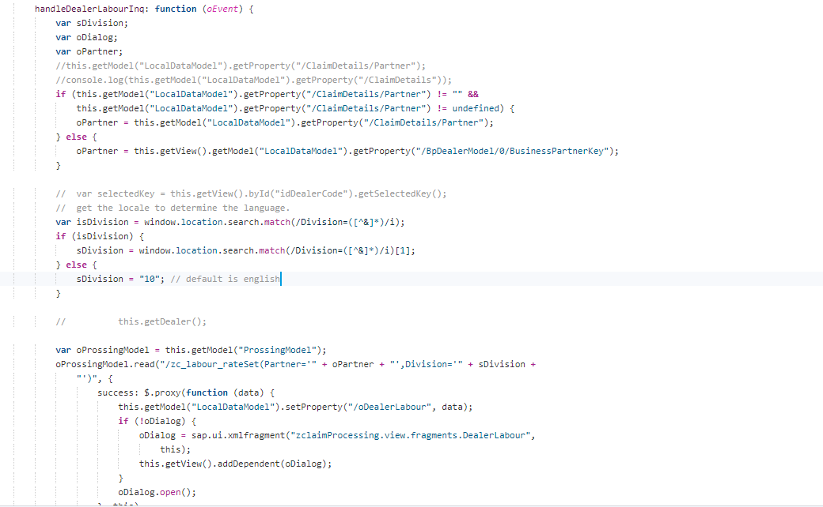

**onPressAgreement()**

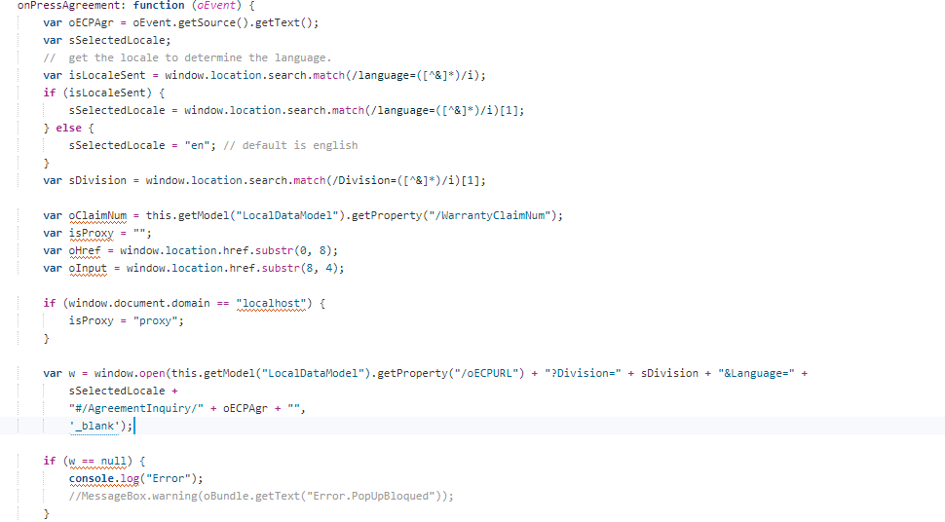

**onPressSearch()**

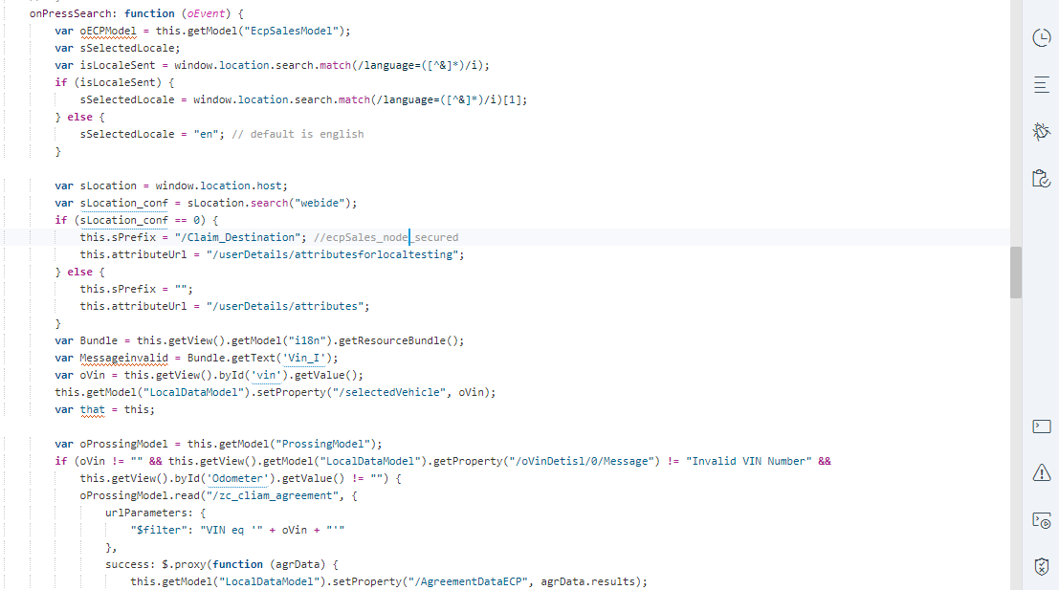

**onPressLookUp()**

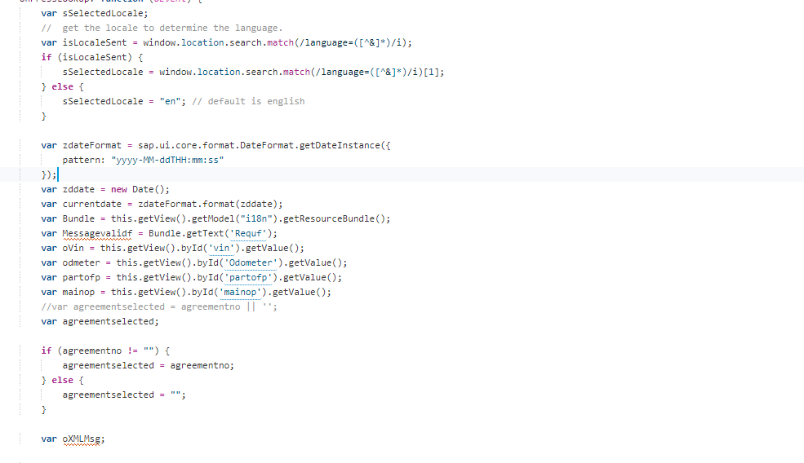

onPressClear()

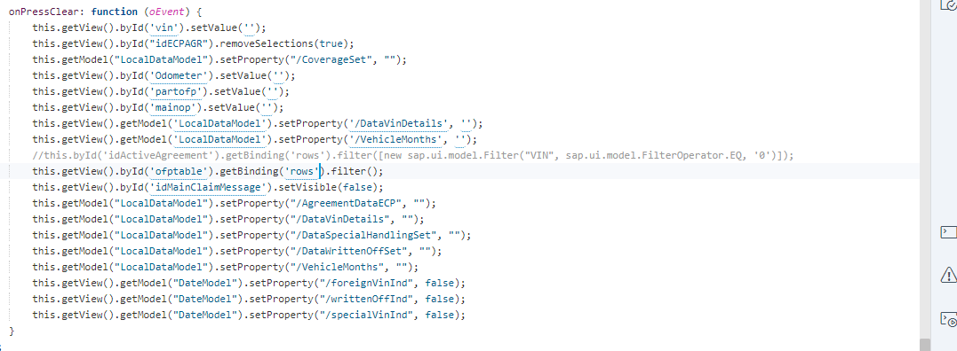

INCIDENT **INC0196563**

In CPS, if we try to attach more than certain documents in claim, it will through an error message to user

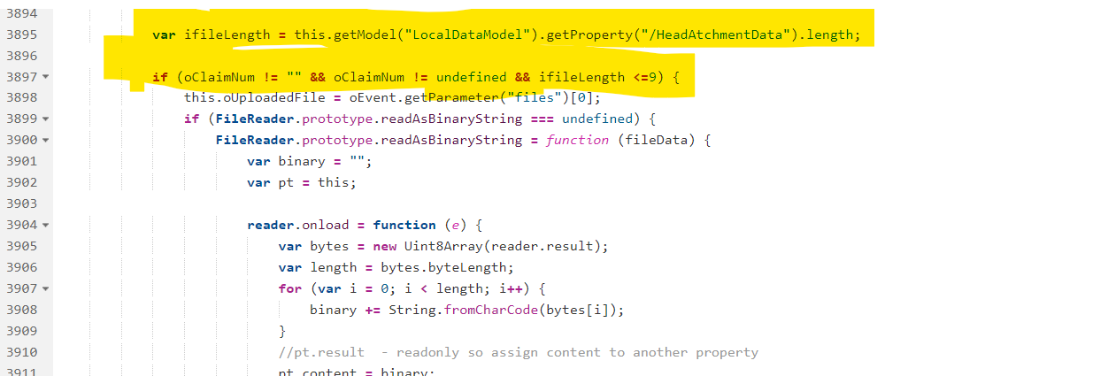

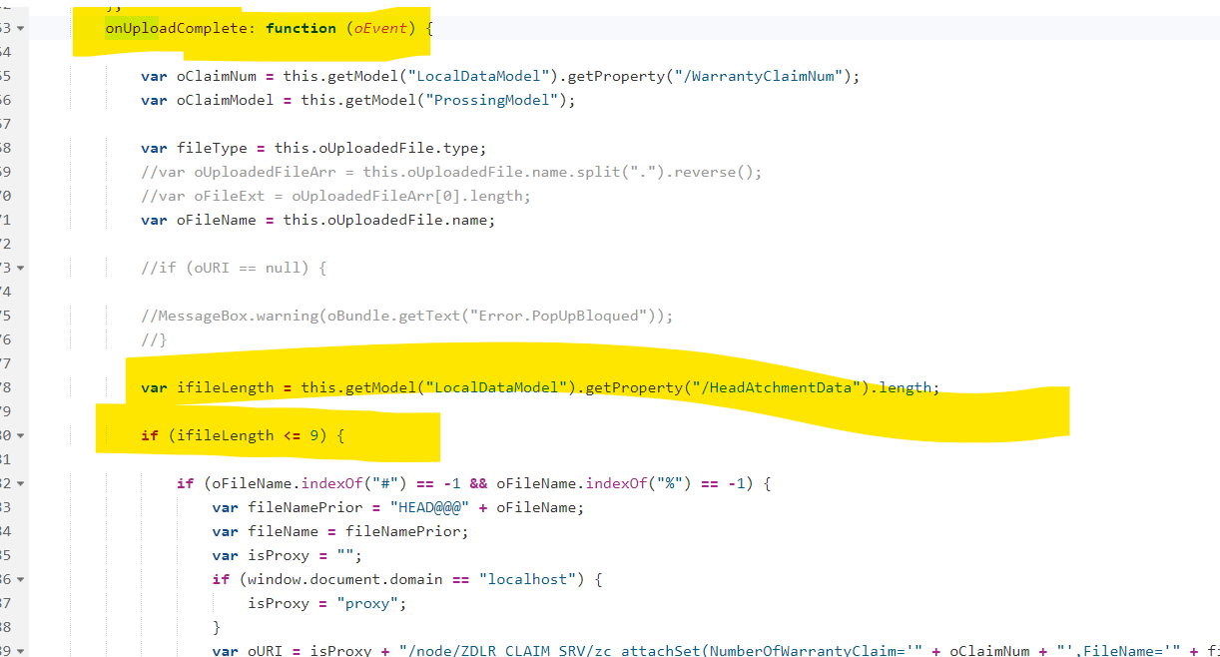

Now error handling done and claim data loading without and error.

**DMND0004037: FedEx Custom Goods Claims Recovery**

1. In Main Claim Section Page for Claim Type ZPPD & ZPTS the field name Outbound Delivery Number should be replaced with Outbound Delivery/Invoice Number.

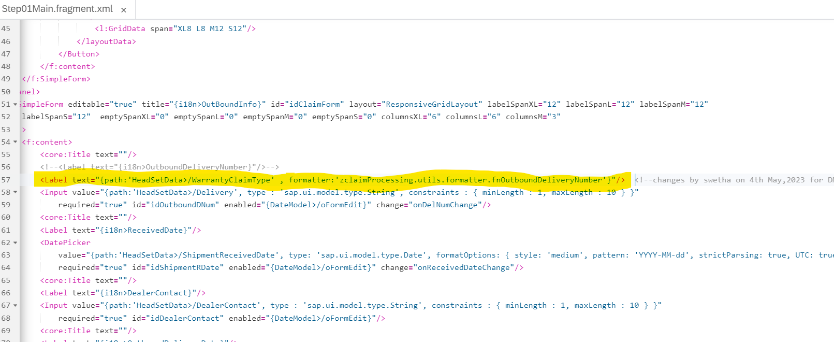

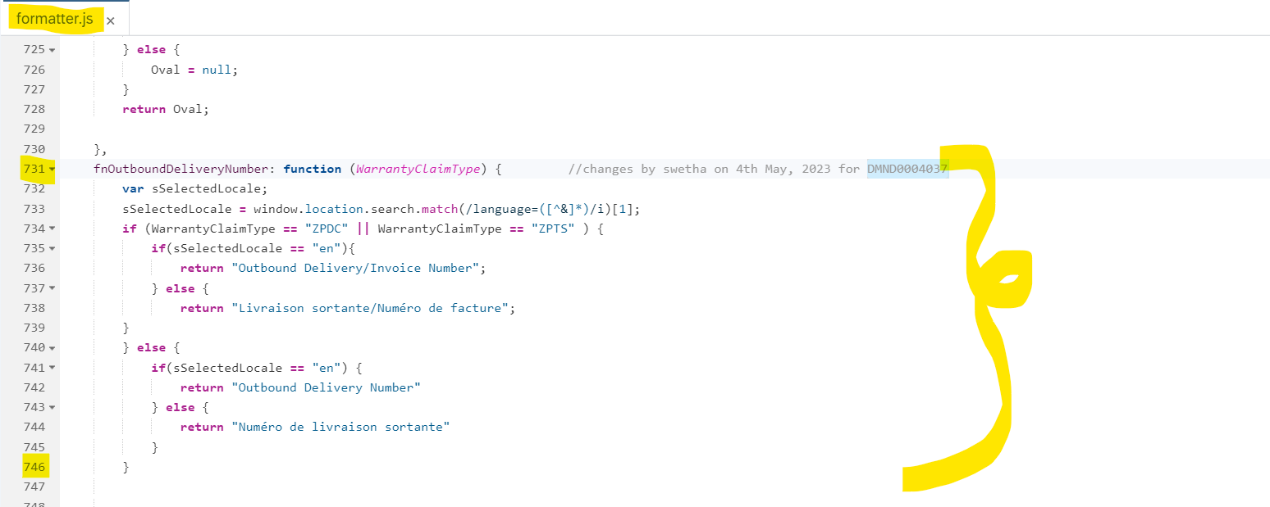

1. In Main Claim Section Page for the Outbound Delivery/Invoice Number Error Popup Message OData team has asked to add Claim-type in the service url.

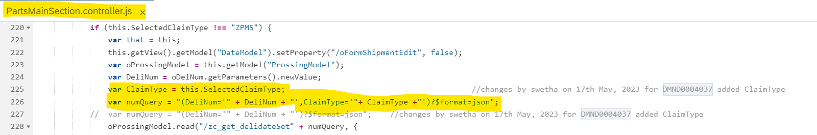

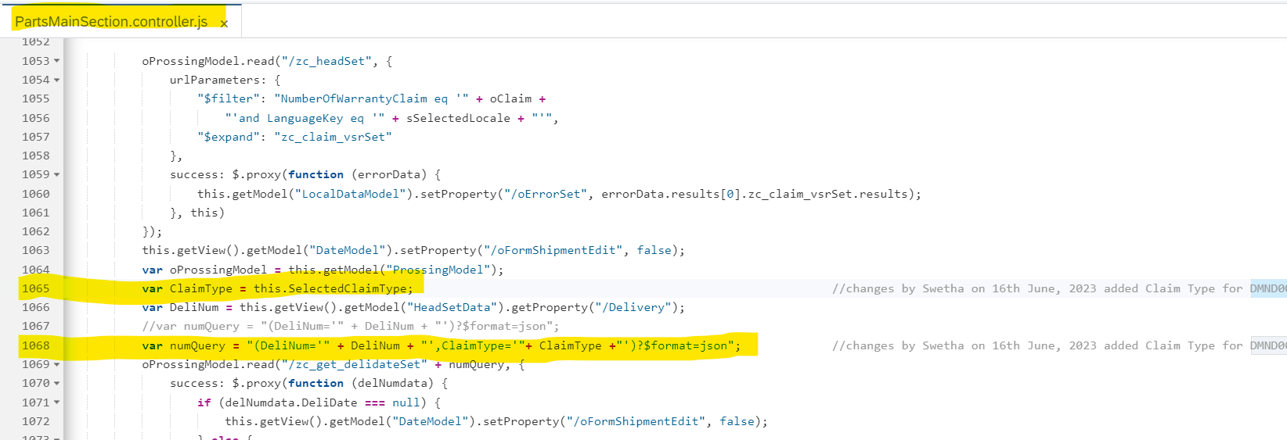

1. For Empty Pop-up message

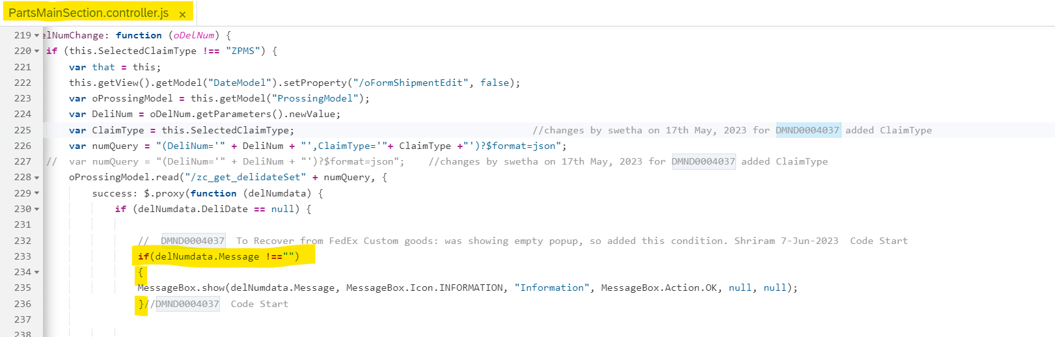

DMND0003836: Add RO Close date field in CPS and SAP-------Start

1)Adding RO Close Date Field

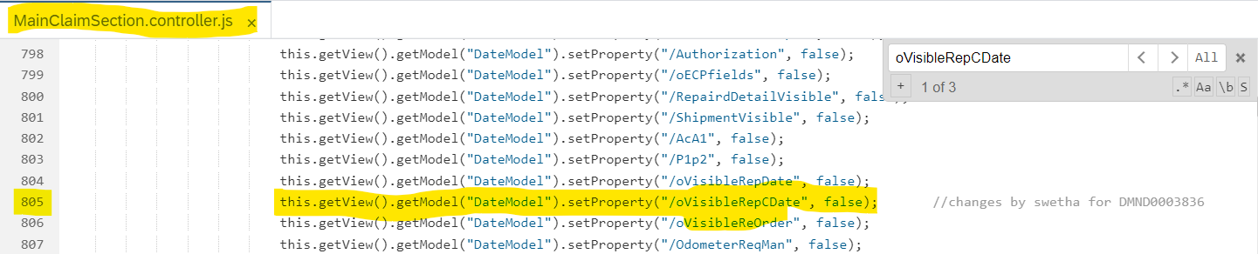

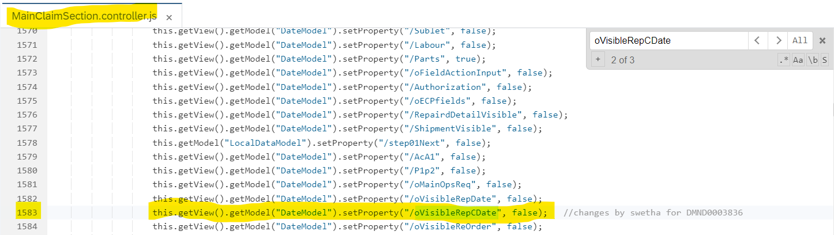

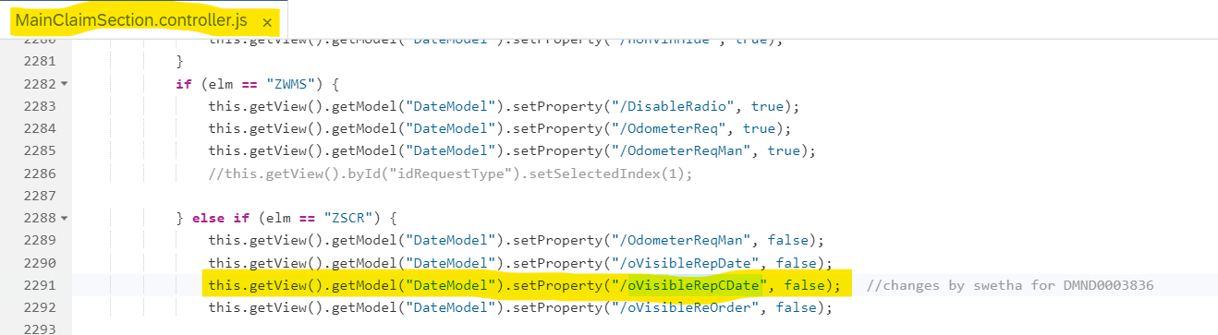

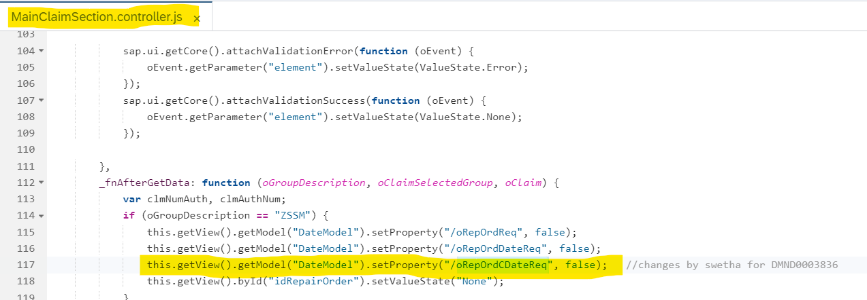

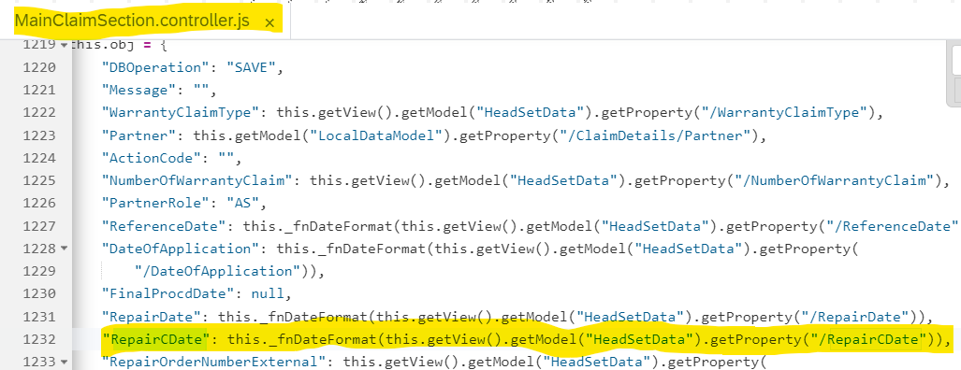

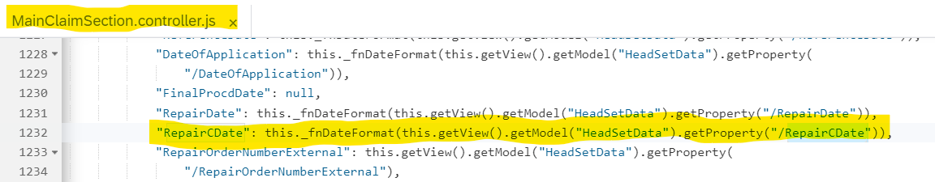

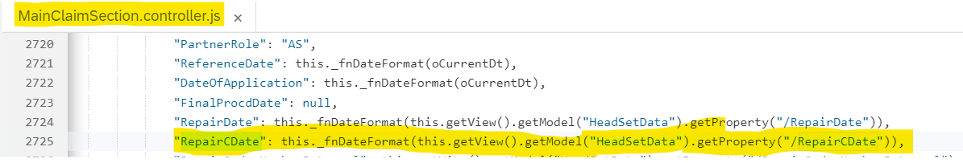

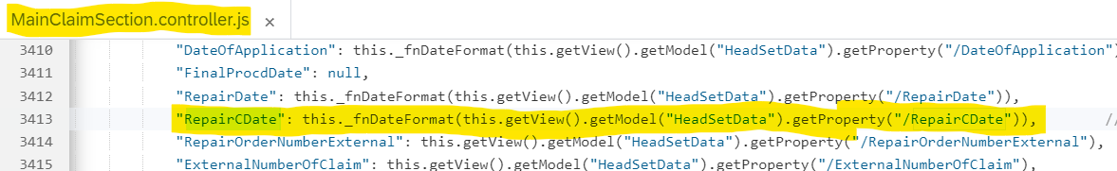

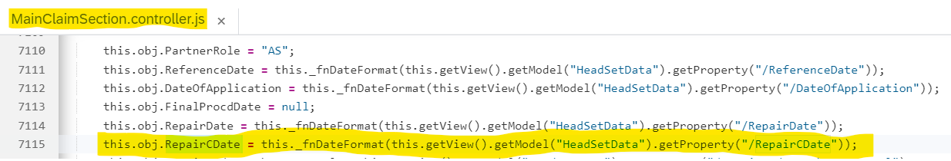

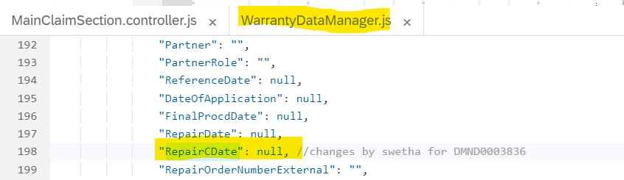

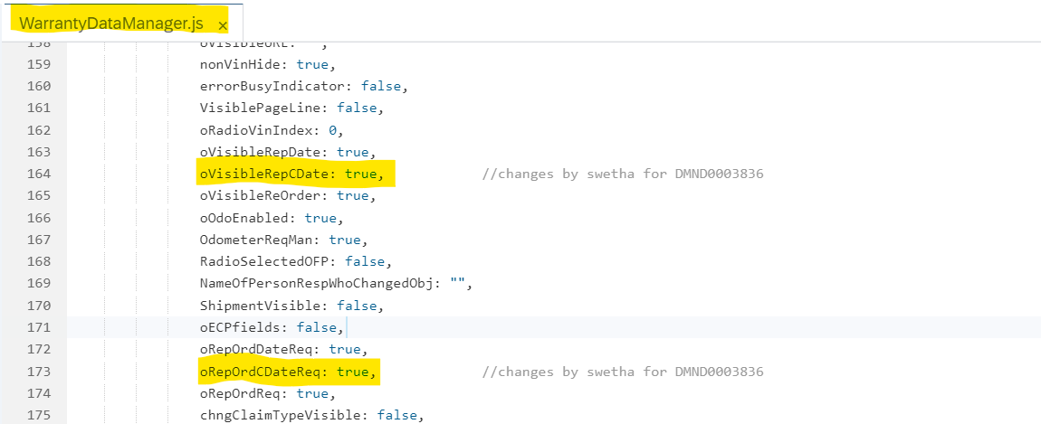

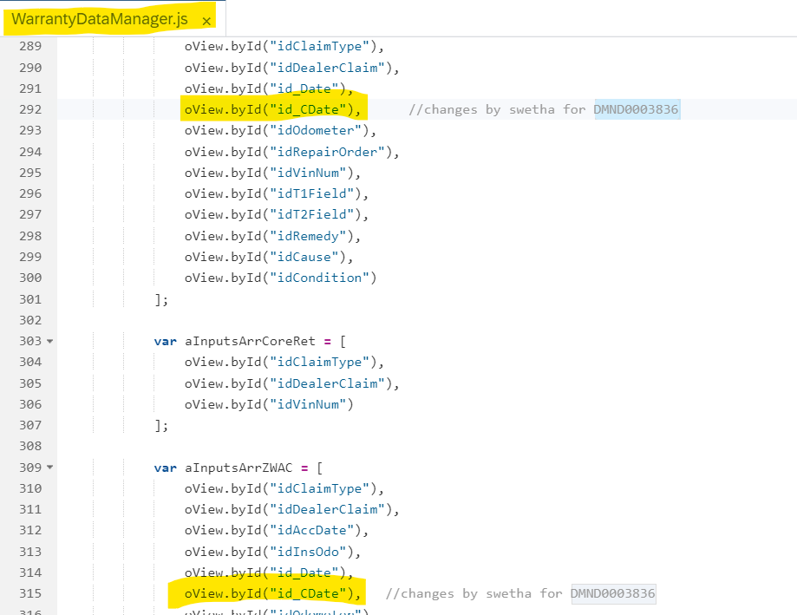

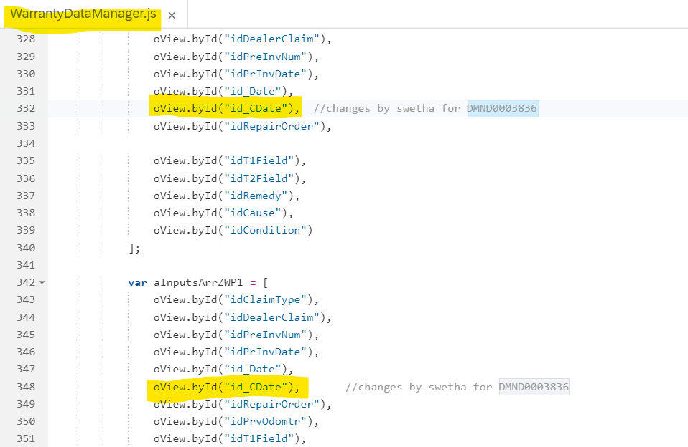

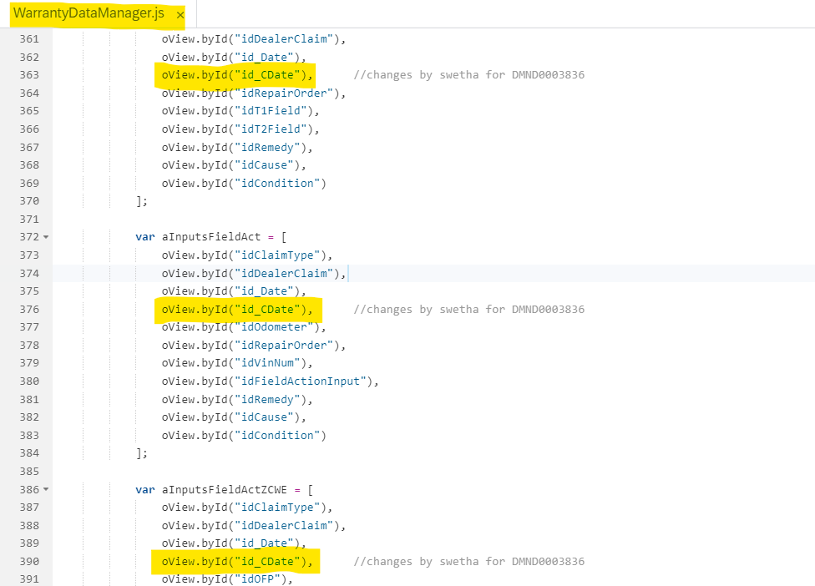

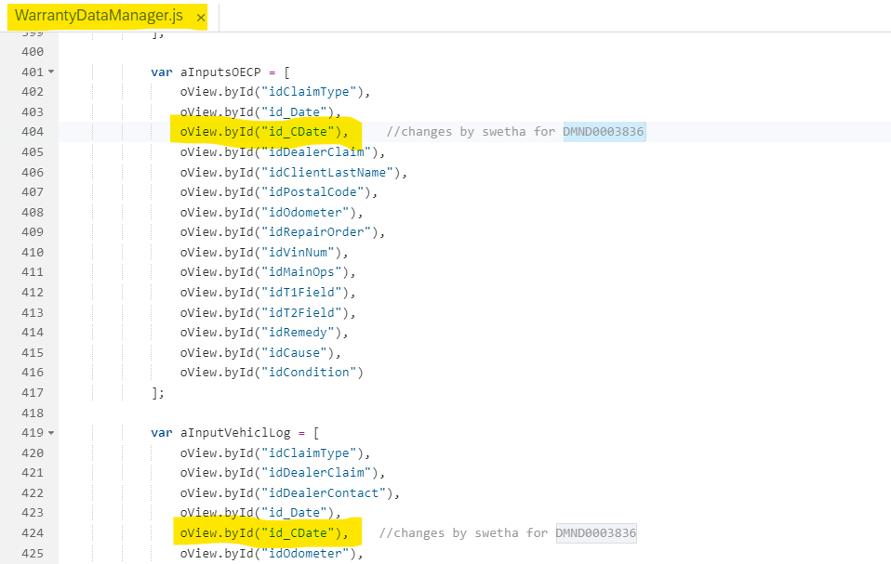

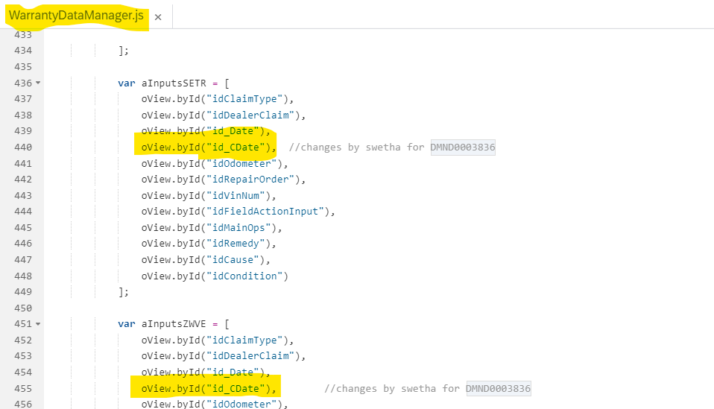

2)Changing Repair Order Field to RO Open Date and adding Validation

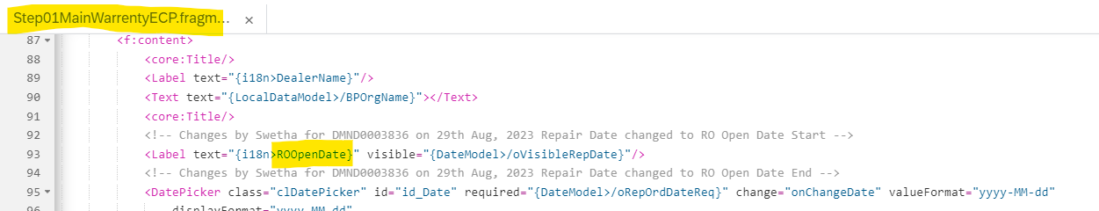

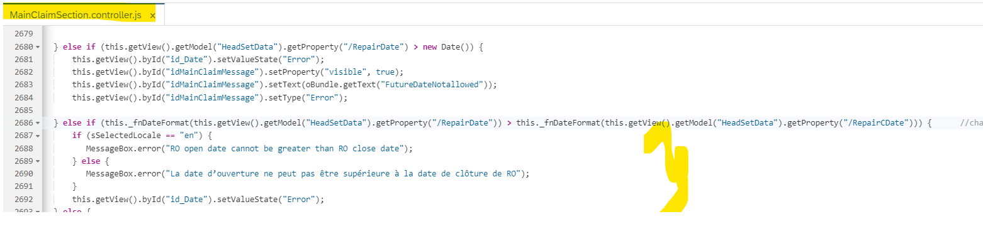

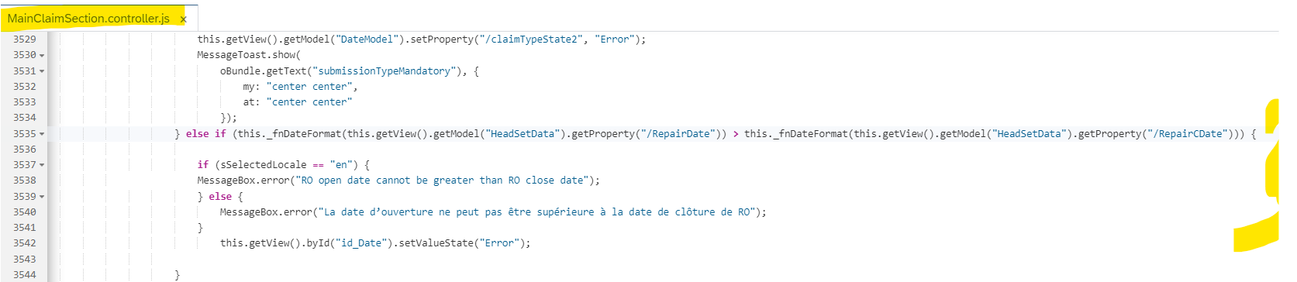

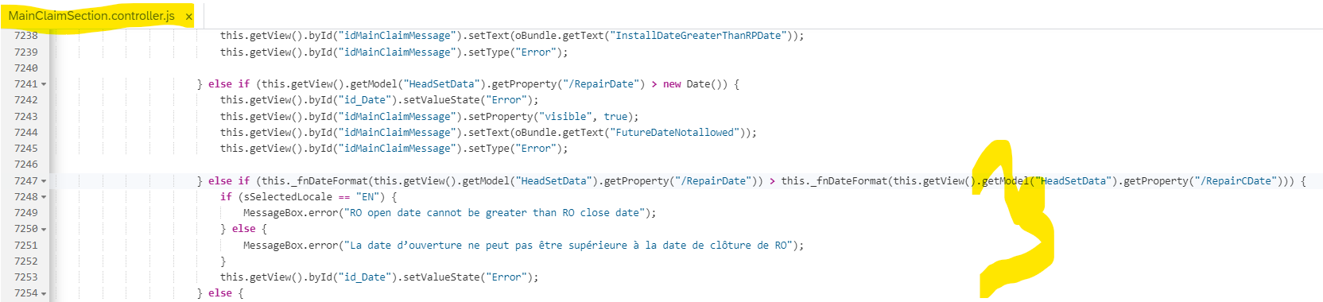

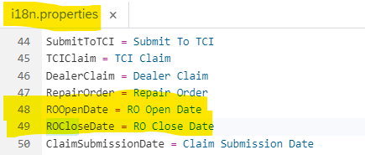

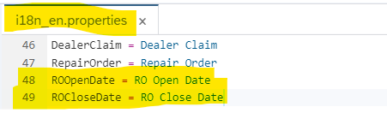

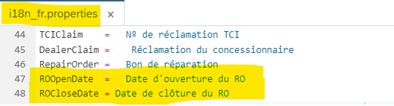

DMND0003836: Add RO Close date field in CPS and SAP-------End

# Component JS Details

* Loads manifest
* Initializes UI Components for application
* Initializes app router
* Initializes i18n resource bundle
* Handles session expiry dialog for the application

# Formatters Details

* favicons.js: Handles icon and language switch for browser title as per logged in user’s division and language
* formatter.js : All formatters available here.

# Patterns Details

# ODATA-Gateway (Back-end)

* Main oData Services:
  + ZECP_SALES_ODATA_SERVICE_SRV
  + Z_VEHICLE_MASTER_SRV
  + API_BUSINESS_PARTNER
  + ZDLR_CLAIM_SRV
* List of Entity Sets:

|  |  |  |  |
| --- | --- | --- | --- |
| Entity set | Filters/key/order | Response | OP |
| ZDLR_CLAIM_SRV | zc_headSet |  | C |
| ZDLR_CLAIM_SRV | zc_headSet  "$filter": NumberOfWarrantyClaim, LanguageKey,  “expand” - zc_claim_commentSet | data | R |
| API_BUSINESS_PARTNER | A_BusinessPartner  "$filter": "BusinessPartner eq '" + oDealer + "'" | data | R |
| API_BUSINESS_PARTNER | A_BusinessPartnerAddress  "$filter": "BusinessPartner eq '" + oCustomer + "' ", "$expand": "to_PhoneNumber,to_FaxNumber,to_EmailAddress" | data | R |
| ZDLR_CLAIM_SRV | zc_cliam_agreement  Filter – VIN | data | R |
| ZDLR_CLAIM_SRV | ZC_GET_FORE_VIN  Filter - p_vhvin | data | R |
| ZDLR_CLAIM_SRV | zc_vehicle_informationSet  Filter – LanguageKey, Vin  Expand - "ZC_SPECIAL_HANDLINGVEHICLESET,  ZC_WRITTENOFFVEHICLESET" | data | R |
| ZDLR_CLAIM_SRV | zc_ecp_agreement  Filter – AgreementNumber | data | R |
| ZDLR_CLAIM_SRV | ZC_CLAIM_HEAD_NEW  Filter – NumberOfWarrantyClaim | Data | R |
| ZDLR_CLAIM_SRV | zc_ecp_vehicle_detailSet  Filter - VIN | Data | R |
| ZDLR_CLAIM_SRV | zc_ecp_valid_vinsSet  Filter - VIN | Data | R |
| ZDLR_CLAIM_SRV | zc_authorization_detailsSet  Filter - AuthorizationNumber |  | D |
| ZECP_SALES_ODATA_SERVICE_SRV | ZC_CLAIM_SUBLET_CODE  Filter - Clmty | Data | U |
| ZDLR_CLAIM_SRV | zc_claim_item_damageSet  Filter – NumberOfWarrantyClaim, LanguageKey |  |  |
| ZDLR_CLAIM_SRV | ZC_CLAIM_SUM  Filter – p_clmno | Data | R |

# Data Source consideration

N/A

|  |  |  |
| --- | --- | --- |
| **Field name / Description** | **Table Field Name** | **Comments / Calculations / Field Manipulations** |
|  |  |  |
|  |  |  |
|  |  |  |
|  |  |  |
|  |  |  |
|  |  |  |
|  |  |  |

# Data Validation

N/A

|  |  |
| --- | --- |
| **Table Field Name** | **Validation Rule** |
|  |  |
|  |  |
|  |  |
|  |  |

# 

* 1. **Notification**



N/A

|  |  |  |  |
| --- | --- | --- | --- |
| **Error** | How error message should be reported | **Error Messages** | **Corrective action** |
|  |  |  |  |
|  |  |  |  |
|  |  |  |  |

* 1. **Restart / Recovery**

N/A

# Security Requirements/ Authorization Details

1. **Dealer User**
2. Will interact with Tire Centre to source Tires and prepare Quotes
3. **Dealer Admin**
   1. Will interact with Tire Centre to source Tires and prepare Quotes
   2. Will maintain Dealer MSRP Markups
4. **Internal TCI User** (mimic what Dealers can do, but under their Internal Dealer Code)
   1. Will interact with Tire Centre to source Tires and prepare Quotes Will maintain Dealer MSRP Mark ups

# Additional Information and attachments

* 1. **Reconciliation Reporting**

If a specific report or additional information is required is required for reconciliation

* 1. **Attachments**

# HANA Artifacts

* 1. **Object List :** List out all the HANA artifacts which is required to be created/changed

|  |  |  |  |  |  |  |  |
| --- | --- | --- | --- | --- | --- | --- | --- |
| Object Name | Object Type | Ref. ABAP Object | Object Description | Action | Package | Delivery Units | Comments |
|  | **Calculation View/ Attribute view/ Analytic view/ Table/**  **DB Procedure** |  |  | Create/  Modify |  |  |  |

* 1. **DB Procedure Details:** Specify the details of DB procedure

**Procedure Name:**

|  |  |  |  |  |  |
| --- | --- | --- | --- | --- | --- |
| Parameter Name | Parameter Type | Parameter Data Type | Data Type | Length | Scale |
|  | **IN/OUT** |  |  |  |  |

**Procedure Logic:**

* 1. **DB Objects (View/Table) :** Specify the details of DB object structure

| View Column | Table Column | SQL Data Type | Dimension | Not Null | Default |
| --- | --- | --- | --- | --- | --- |
|  |  |  |  |  |  |
|  |  |  |  |  |  |
|  |  |  |  |  |  |
|  |  |  |  |  |  |

**Sample View Screenshot:**

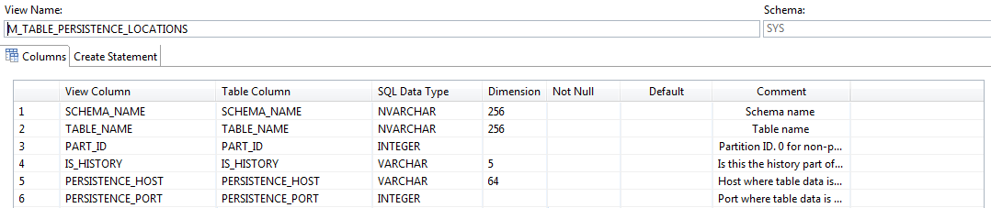

# 21. Unit Test Plan

Normal Functionality - test cases that ensure the workflow functions as it should. (e.g. updates fields correctly, processes all records)

| **Test Condition** | **Step** | **Step Description** | **Test Data** | **Expected Result** | **Actual Result** | **Executed By/Date** | **Remarks** |
| --- | --- | --- | --- | --- | --- | --- | --- |
|  |  |  |  |  |  |  |  |
|  |  |  |  |  |  |  |  |

Exception - special logic or exceptions (e.g. do not process Government Markets customers, only process pre-packs)

| **Test Condition** | **Step** | **Step Description** | **Test Data** | **Expected Result** | **Actual Result** | **Executed By/Date** | **Remarks** |
| --- | --- | --- | --- | --- | --- | --- | --- |
|  |  |  |  |  |  |  |  |
|  |  |  |  |  |  |  |  |

Error Handling - functionality in case of errors (e.g. Customer not found, Record already exists)

| **Test Condition** | **Step** | **Step Description** | **Test Data** | **Expected Result** | **Actual Result** | **Executed By/Date** | **Remarks** |
| --- | --- | --- | --- | --- | --- | --- | --- |
|  |  |  |  |  |  |  |  |

